UNITED STATES
SECURITIES AND EXCHANGE COMMISSION
Washington, D.C. 20549
_______________________________
FORM 8-K
_______________________________
CURRENT REPORT
Pursuant to Section 13 or 15(d) of the
Securities Exchange Act of 1934
Date of Report (Date of earliest event reported): August 10, 2026
Public Policy Holding Company, Inc.
(Exact name of registrant as specified in its charter)
Delaware |  |  |  |  |  | 001-43077 |  |  |  |  |  | 87-3557229
(State or other jurisdiction of  incorporation) |  |  |  |  |  | (Commission  File Number) |  |  |  |  |  | (IRS Employer  Identification No.)
800 North Capitol Street NW, Suite 800,  Washington, DC |  |  |  |  |  | 20002
(Address of principal executive offices) |  |  |  |  |  | (Zip Code)
Registrant’s telephone number, including area code: (202) 688-0020
Not Applicable
(Former name or former address, if changed since last report)
_______________________________
Check the appropriate box below if the Form 8-K filing is intended to simultaneously satisfy the filing obligation of the registrant under any of the following provisions (see General Instruction A.2. below):
o |  |  |  |  |  | Written communications pursuant to Rule 425 under the Securities Act (17 CFR 230.425)
o |  |  |  |  |  | Soliciting material pursuant to Rule 14a-12 under the Exchange Act (17 CFR 240.14a-12)
o |  |  |  |  |  | Pre-commencement communications pursuant to Rule 14d-2(b) under the Exchange Act (17 CFR 240.14d-2(b))
o |  |  |  |  |  | Pre-commencement communications pursuant to Rule 13e-4(c) under the Exchange Act (17 CFR 240.13e-4(c))
Securities registered pursuant to Section 12(b) of the Act:
Title of each class |  |  |  |  |  | Trading Symbol(s) |  |  |  |  |  | Name of each exchange on which registered
Common Stock, $0.001 par value |  |  |  |  |  | PPHC |  |  |  |  |  | NASDAQ
Indicate by check mark whether the registrant is an emerging growth company as defined in Rule 405 of the Securities Act of 1933 (§230.405 of this chapter) or Rule 12b-2 of the Securities Exchange Act of 1934 (§240.12b-2 of this chapter).
Emerging growth company x
If an emerging growth company, indicate by check mark if the registrant has elected not to use the extended transition period for complying with any new or revised financial accounting standards provided pursuant to Section 13(a) of the Exchange Act. x

Item 2.02 Results of Operations and Financial Condition.
On August 10, 2026, Public Policy Holding Company, Inc. (the “Company”) issued a press release announcing its financial results for the three and six months ended June 30, 2026. A copy of the Company’s press release is furnished as Exhibit 99.1 to this Current Report on Form 8-K and is incorporated by reference herein.
In addition, the Company is furnishing a copy of an investor presentation (the “Presentation”) that the Company intends to use, in whole or in part, in one or more meetings with investors or analysts, including in a webcast on August 10, 2026 at 4:30 p.m. (Eastern Time). A copy of the Presentation is furnished as Exhibit 99.2 to this Current Report on Form 8-K and is incorporated by reference herein.
The information in this Current Report on Form 8-K, including Exhibits 99.1 and 99.2 furnished hereto, shall not be deemed “filed” for purposes of Section 18 of the Securities Exchange Act of 1934, as amended (the “Exchange Act”), or otherwise subject to the liabilities of that section, nor shall it be deemed incorporated by reference in any filing under the Securities Act of 1933, as amended, or the Exchange Act, except as expressly set forth in such filing.

Item 9.01 Financial Statements and Exhibits.
(d)Exhibits
Exhibit No. |  |  |  |  |  | Description
99.1 |  |  |  |  |  | Press release, dated August 10, 2026
99.2 |  |  |  |  |  | Investor presentation materials, dated August 10, 2026
104 |  |  |  |  |  | Cover Page Interactive Data File (embedded within the Inline XBRL document).

SIGNATURES
Pursuant to the requirements of the Securities Exchange Act of 1934, the registrant has duly caused this report to be signed on its behalf by the undersigned hereunto duly authorized.
Date: August 10, 2026
 |  |  | Public Policy Holding Company, Inc.
 |  |  | By: |  |  | /s/ George Stewart Hall
 |  |  | Name: |  |  | George Stewart Hall
 |  |  | Title: |  |  | Chief Executive Officer

Public Policy Holding Company, Inc. Announces Q2 2026 Financial Results
Continued Revenue Growth and Disciplined M&A Execution in First Half of 2026; Raises Full Year 2026 Guidance to Reflect Recent Acquisitions

•H1 2026 revenue growth of 16.3% with organic revenue growth of 4.4%, compared to H1 2025
•Completed one acquisition in H1 2026; post-period, completed two acquisitions
•Dividend of $7.0 million paid in Q2 on 2025 results, one of two semi-annual payments
•Net Debt remains low at $5.2 million in Q2 (Q1: $1.8 million)
WASHINGTON, DC – August 10, 2026 (GLOBE NEWSWIRE) – Public Policy Holding Company, Inc. ("PPHC," "Company," "Group") (Nasdaq: PPHC and AIM: PPHC.L), a leading global strategic communications provider offering a comprehensive range of advisory services in the areas of Government Relations, Corporate Communications, and Public Affairs, today reported unaudited financial results for the quarter ended June 30, 2026 ("Q2 2026").

Q2 2026 Financial Highlights
•Revenue increased 7.3% over Q2 2025 to $52.1 million
•Organic revenue growth of 3.9% over Q2 2025
•GAAP net loss of $3.7 million, an improvement of 34.8% compared to $5.7 million in Q2 2025
•Adjusted EBITDA of $12.3 million, down 4.4% over Q2 2025, achieved at a 23.5% margin; — reflecting a particularly strong prior-year comparable period, incremental public company costs incurred following the January 2026 U.S. IPO, and, to a lesser extent, a shift in business mix
•Adjusted Net Income of $10.6 million, down 11.0% over Q2 2025
•GAAP basic and diluted loss per share of $0.19 an improvement as compared to $0.44 in Q2 2025
•Adjusted EPS, fully diluted of $0.34 compared to $0.45 in Q2 2025, reflecting the higher share count following January 2026 U.S. IPO

H1 2026 Financial Highlights
•Revenue increased 16.3% over H1 2025 to $102.3 million
•Organic Revenue growth of 4.4% over H1 2025
•GAAP Net Loss of $15.2 million compared to $16.3 million in H1 2025
•Adjusted EBITDA of $23.4 million, up 9.3% over H1 2025, achieved at a 22.9% margin
•Adjusted Net Income of $17.9 million, up 15.3% over H1 2025
•GAAP Basic and diluted loss per share of $0.68 an improvement as compared to $1.06 in H1 2025
•Adjusted EPS, fully diluted of $0.59 compared to $0.60 in H1 2025, reflecting the higher share count following the January 2026 U.S. IPO

Adjusted EBITDA, Adjusted EBITDA margin, Adjusted EBITDA Incl. M&A expense, Adjusted net income, Adjusted EPS, fully diluted, Organic Revenue Growth and Adjusted Free Cash Flow, are non-GAAP financial measures, as defined and reconciled to the nearest related GAAP measure below.

Stewart Hall, CEO of PPHC, commented:
"Our performance in the first half of 2026 demonstrates the strength of the platform we have built. Our clients operate in an increasingly complex political, regulatory and reputational environment; one in which swift access to senior, integrated counsel across multiple spheres of influence matters more than ever. Our strategy of building a diversified yet
1

complementary group of firms, offering premier counsel across key US and European markets, differentiates PPHC and continues to win us high-value mandates.

"The first half reflected that positioning, with H1 revenue and profit growth year-over-year and continued momentum across the business. Our revenue base remains highly diversified, and we ended the period serving approximately 1,500 clients, including representations of approximately half of the Fortune 100. We now cover every area in strategic communications across our key global markets, providing a strong foundation for further organic growth. At the same time, our pipeline of acquisition opportunities and of senior talent remains strong. With a growing and resilient platform and an active M&A program, we enter the second half with confidence."

Roel Smits, CFO of PPHC, Commentary and Financial Guidance:
"PPHC enters the second half of 2026 from a position of financial strength. Our first-half performance reflects continued revenue growth, Adjusted EBITDA growth with margins improving sequentially from Q1 to Q2, while the proceeds from our U.S. IPO have enhanced our ability to execute on our acquisition strategy. We continue to manage the business back towards our 25% Adjusted EBITDA margin target as recently acquired businesses scale and as we absorb the first full year of U.S. public company costs. We remain focused on balancing investment in future growth with profitability, and we are pleased to raise our full-year guidance to reflect the contribution from acquisitions completed and announced during the year. With a strong balance sheet, recurring client relationships and a robust acquisition pipeline in North America, UK, and mainland Europe. We believe PPHC is well positioned to continue creating value for shareholders."
Financial Outlook
For full year 2026, PPHC is raising its guidance to reflect the expected in-year contribution of the acquisitions completed and announced in YTD 2026:
•Revenue in the range of $213 million to $216 million (previously $205 million to $209 million)
•Adjusted EBITDA in the range of $48.5 million to $50.5 million (previously $46 million to $48 million), reflecting an adjusted margin between 22.5% and 23.5% (previously 22% to 23%)
•Organic Revenue Growth of approximately 5%, unchanged
The increase in guidance is attributable to completed and announced acquisitions; the Company's outlook for the underlying business is unchanged. Guidance continues to exclude the impact of any future acquisitions. The Company does not provide a reconciliation of forward-looking non-GAAP measures to the most directly comparable GAAP measures because the reconciling items, including acquisition-related charges, share-based accounting charges and changes in the fair value of contingent consideration, cannot be reasonably predicted without unreasonable effort.

Operational Highlights
•Significant progress in line with the Group’s stated growth strategy, with earnings-accretive acquisitions and senior hires adding complementary services and expertise for the Group’s international client base:
•Completed the acquisition of Westminster Policy Partners Limited (“WPI”) on April 1, 2026, expanding Group-wide capabilities in economic and policy research and providing cross-referral revenue opportunities.
•Post-period end, completed the acquisition of Tancredi Intelligent Communication Ltd (“Tancredi”) on July 1, 2026, adding financial, corporate and litigation communications expertise as the first member of TrailRunner Group, the Group’s corporate and financial communications platform, and expanding international operations in London and Milan.
•Post-period end, completed the acquisition of The Advocacy Partners on August 1, 2026, one of Florida's pre-eminent government relations firms, completing a coast-to-coast state government relations affairs footprint.
•Strengthened senior talent with significant new hires in Government Relations, Corporate Communications, and Public Affairs.
2

•Revenue diversification further enhanced with the top 10 Group clients representing 7.5% of revenue in H1 2026 (H1 2025: 9.4%). Revenue mix by segment also diversified further, with the Corporate Communications & Public Affairs segment, the Group's second largest reporting segment, growing to represent 35.7% of total revenue in H1 2026 (H1 2025: 32.0%).
•Grew the client base to approximately 1,500, including representations of approximately half of the Fortune 100 and many more via trade associations, reflecting continued high retention and new-business generation.
•The Group ended H1 2026 with 476 employees (H1 2025: 447).

2026 Segment Results
•Government Relations Consulting grew at 9.8% for H1 2026, as compared to H1 2025 as a consequence of continued organic growth of 6.3% in tandem with the acquisitions of Pine Cove Strategies, LLC ("Pine Cove") (completed July 11, 2025) and WPI (completed April 1, 2026). The margin of Segment Adjusted pre-bonus EBITDA marginally increased to 46.7%, reflecting the consistent pricing of retainer contracts both at U.S. Federal and State level.
•Corporate Communications & Public Affairs Consulting increased by 29.5% for H1 2026, as compared to H1 2025, driven by the impact of the acquisitions of TrailRunner International, LLC ("TrailRunner") (completed April 1, 2025) and WPI (completed April 1, 2026), offset by slow organic growth, which was down 0.9%. The margin of Segment Adjusted pre-bonus EBITDA decreased by 0.9pts to 24.8% in H1 2026, reflecting the inclusion of acquired revenues, representing operating margins that are lower than the Group's average.
•Compliance and Insights Services continued its strong growth at 12.8% for H1 2026, as compared to H1 2025 (reported and organic) as a result of high renewal rates, price increases, and new client wins, reflective of a unique and high value-added offering. The margin of Segment Adjusted pre-bonus EBITDA was 50.2%, reflecting the strong pricing of subscription-based contracts in this area, in combination with the increased use of technology in servicing our clients.

Conference Call Webcast Information
PPHC management will host a conference call to discuss the Company’s financial results today at 4:30 p.m. Eastern Time. The call will be led by Stewart Hall, Chief Executive Officer, Roel Smits, Chief Financial Officer, and Thomas Gensemer, Chief Strategy Officer.
Date: Monday, August 10, 2026
Time: 4:30 p.m. Eastern Time
Webcast: Participants may access the conference call via live webcast at https://edge.media-server.com/mmc/p/mxsggmoi

Dial-in: To participate via telephone, please register in advance and receive a unique PIN at https://register-conf.media-server.com/register/BI39227e4481c34165806143b77781608f

A replay of the webcast of the conference call will be available on the Investor Relations section of the Company’s website at investors.pphcompany.com.
This announcement contains inside information under the UK Market Abuse Regulation. The person responsible for arranging for the release of this announcement on behalf of the Company is Roel Smits, CFO.

3

About PPHC
Incorporated in 2014, PPHC is a global strategic communications platform that supports clients in enhancing and defending their reputations, advancing policy objectives, managing regulatory risk, and engaging with federal and state-level policymakers, stakeholders, media, and the public.
Engaged by approximately 1,500 clients, including companies, trade associations and non-governmental organizations, PPHC is active in all major sectors of the economy, including healthcare and pharmaceuticals, financial services, energy, technology, telecoms and transportation.
With operations across the United States and internationally, PPHC's services include government relations, public affairs and corporate communications, research and analytics, digital advocacy campaigning, and compliance support. The Company's shares are admitted to trading on the Nasdaq Global Market and on AIM, a market operated by the London Stock Exchange, under the ticker symbol "PPHC".
For more information, visit www.pphcompany.com.

Financial Review
Certain monetary amounts, percentages and other figures included elsewhere in this earnings release have been subject to rounding adjustments. Accordingly, figures shown as totals in certain tables or charts may not be the arithmetic aggregation of the figures that precede them, and figures expressed as percentages in the text may not total 100% or, as applicable, when aggregated may not be the arithmetic aggregation of the percentages that precede them.

Adjusted Profit & Loss Statement
 |  |  | (Amounts in millions, except per share data)
 |  |  | Three months ended June 30, |  |  |  |  |  |  |  |  |  |  |  |  |  |  |  |  |  |  |  |  |  |  |  | Six Months ended June 30,
 |  |  | 2026 |  |  |  |  |  | 2025 |  |  |  |  |  | $ Change |  |  |  |  |  | % Change |  |  |  |  |  | 2026 |  |  |  |  |  | 2025 |  |  |  |  |  | $ Change |  |  |  |  |  | % Change
Revenue |  |  | $ | 52.1 |  |  |  |  | $ | 48.6 |  |  |  |  | $ | 3.6 |  |  |  |  | 7.3 |  | % |  |  |  | $ | 102.3 |  |  |  |  | $ | 87.9 |  |  |  |  | $ | 14.4 |  |  |  |  | 16.3 |  | %
GAAP Net loss |  |  | (3.7) |  |  |  |  |  | (5.7) |  |  |  |  |  | 2.0 |  |  |  |  |  | 34.8 |  | % |  |  |  | (15.2) |  |  |  |  |  | (16.3) |  |  |  |  |  | 1.1 |  |  |  |  |  | 6.8 |  | %
Adjusted EBITDA |  |  | 12.3 |  |  |  |  |  | 12.8 |  |  |  |  |  | (0.6) |  |  |  |  |  | (4.4) |  | % |  |  |  | 23.4 |  |  |  |  |  | 21.4 |  |  |  |  |  | 2.0 |  |  |  |  |  | 9.3 |  | %
Adjusted EBITDA margin |  |  | 23.5 |  | % |  |  |  | 26.4 |  | % |  |  |  | (2.9) |  | pts |  |  |  |  |  |  |  |  |  | 22.9 |  | % |  |  |  | 24.4 |  | % |  |  |  | (1.5) |  | pts
M&A expense |  |  | (0.8) |  |  |  |  |  | (0.1) |  |  |  |  |  | (0.7) |  |  |  |  |  | (883.1) |  | % |  |  |  | (1.1) |  |  |  |  |  | (0.3) |  |  |  |  |  | (0.8) |  |  |  |  |  | (281.4) |  | %
Adjusted EBITDA incl M&A expense |  |  | 11.5 |  |  |  |  |  | 12.7 |  |  |  |  |  | (1.3) |  |  |  |  |  | (10.1) |  | % |  |  |  | 22.4 |  |  |  |  |  | 21.2 |  |  |  |  |  | 1.2 |  |  |  |  |  | 5.8 |  | %
Depreciation |  |  | (0.1) |  |  |  |  |  | (0.1) |  |  |  |  |  | (0.0) |  |  |  |  |  | (5.4) |  | % |  |  |  | (0.1) |  |  |  |  |  | (0.1) |  |  |  |  |  | (0.0) |  |  |  |  |  | (5.3) |  | %
Adjusted EBIT |  |  | 11.4 |  |  |  |  |  | 12.7 |  |  |  |  |  | (1.3) |  |  |  |  |  | (10.2) |  | % |  |  |  | 22.3 |  |  |  |  |  | 21.1 |  |  |  |  |  | 1.2 |  |  |  |  |  | 5.8 |  | %
Net interest |  |  | (0.5) |  |  |  |  |  | (0.8) |  |  |  |  |  | 0.4 |  |  |  |  |  | 43.7 |  | % |  |  |  | (1.3) |  |  |  |  |  | (1.4) |  |  |  |  |  | 0.2 |  |  |  |  |  | 12.4 |  | %
Adjusted EBT |  |  | 10.9 |  |  |  |  |  | 11.9 |  |  |  |  |  | (0.9) |  |  |  |  |  | (7.8) |  | % |  |  |  | 21.0 |  |  |  |  |  | 19.6 |  |  |  |  |  | 1.4 |  |  |  |  |  | 7.1 |  | %
Taxes |  |  | (0.4) |  |  |  |  |  | 0.0 |  |  |  |  |  | (0.4) |  |  |  |  |  | (1545.8) |  | % |  |  |  | (3.1) |  |  |  |  |  | (4.1) |  |  |  |  |  | 1.0 |  |  |  |  |  | 24.4 |  | %
Effective tax rate |  |  | 3.2 |  | % |  |  |  | (0.2) |  | % |  |  |  | 3.4 |  | pts |  |  |  |  |  |  |  |  |  | 14.7 |  | % |  |  |  | 20.8 |  | % |  |  |  | (6.1) |  | pts
Adjusted Net Income |  |  | $ | 10.6 |  |  |  |  | $ | 11.9 |  |  |  |  | $ | (1.3) |  |  |  |  | (11.0) |  | % |  |  |  | $ | 17.9 |  |  |  |  | $ | 15.6 |  |  |  |  | $ | 2.4 |  |  |  |  | 15.3 |  | %
Adjusted Net Income margin |  |  | 20.3 |  | % |  |  |  | 24.5 |  | % |  |  |  | (4.2) |  | pts |  |  |  |  |  |  |  |  |  | 17.5 |  | % |  |  |  | 17.7 |  | % |  |  |  | (0.2) |  | pts
GAAP basic and diluted loss per share |  |  | $ | (0.19) |  |  |  |  | $ | (0.44) |  |  |  |  | $ | 0.24 |  |  |  |  | 55.6 |  | % |  |  |  | $ | (0.68) |  |  |  |  | $ | (1.06) |  |  |  |  | $ | 0.39 |  |  |  |  | 36.3 |  | %
Adjusted EPS ($) (basic) |  |  | $ | 0.36 |  |  |  |  | $ | 0.48 |  |  |  |  | $ | (0.12) |  |  |  |  | (25.6) |  | % |  |  |  | $ | 0.63 |  |  |  |  | $ | 0.64 |  |  |  |  | $ | (0.01) |  |  |  |  | (1.8) |  | %
Adjusted EPS ($) (fully diluted) |  |  | $ | 0.34 |  |  |  |  | $ | 0.45 |  |  |  |  | $ | (0.12) |  |  |  |  | (25.4) |  | % |  |  |  | $ | 0.59 |  |  |  |  | $ | 0.60 |  |  |  |  | $ | (0.01) |  |  |  |  | (1.5) |  | %

4

Bridge from Adjusted to Reported Results
 |  |  | (Amounts in millions, except percentages)
 |  |  | Three months ended June 30, |  |  |  |  |  |  |  |  |  |  |  |  |  |  |  |  |  |  |  |  |  |  |  | Six months ended June 30,
 |  |  | 2026 |  |  |  |  |  | 2025 |  |  |  |  |  | $ Change |  |  |  |  |  | % Change |  |  |  |  |  | 2026 |  |  |  |  |  | 2025 |  |  |  |  |  | $ Change |  |  |  |  |  | % Change
Adjusted Net Income |  |  | $ | 10.6 |  |  |  |  | $ | 11.9 |  |  |  |  | $ | (1.3) |  |  |  |  | (11.0) |  | % |  |  |  | $ | 17.9 |  |  |  |  | $ | 15.6 |  |  |  |  | $ | 2.4 |  |  |  |  | 15.3 |  | %
Share-based accounting charge |  |  | (7.4) |  |  |  |  |  | (7.4) |  |  |  |  |  | 0.0 |  |  |  |  |  | 0.4 |  | % |  |  |  | (14.6) |  |  |  |  |  | (14.8) |  |  |  |  |  | 0.2 |  |  |  |  |  | 1.3 |  | %
M&A: Post-combination compensation |  |  | (4.2) |  |  |  |  |  | (5.3) |  |  |  |  |  | 1.1 |  |  |  |  |  | 21.4 |  | % |  |  |  | (7.0) |  |  |  |  |  | (8.8) |  |  |  |  |  | 1.7 |  |  |  |  |  | 19.8 |  | %
M&A: bargain purchase charge |  |  | 0.8 |  |  |  |  |  | — |  |  |  |  |  | 0.8 |  |  |  |  |  | — |  |  |  |  |  | 0.9 |  |  |  |  |  | — |  |  |  |  |  | 0.9 |  |  |  |  |  | —
M&A: change in contingent consideration |  |  | (0.9) |  |  |  |  |  | (1.7) |  |  |  |  |  | 0.8 |  |  |  |  |  | 47.3 |  | % |  |  |  | (7.2) |  |  |  |  |  | (2.7) |  |  |  |  |  | (4.5) |  |  |  |  |  | (168.8) |  | %
Long Term Incentive Program charges |  |  | (1.1) |  |  |  |  |  | (1.5) |  |  |  |  |  | 0.5 |  |  |  |  |  | 30.0 |  | % |  |  |  | (2.0) |  |  |  |  |  | (2.7) |  |  |  |  |  | 0.6 |  |  |  |  |  | 23.3 |  | %
Amortization intangibles |  |  | (1.6) |  |  |  |  |  | (1.7) |  |  |  |  |  | 0.1 |  |  |  |  |  | 6.8 |  | % |  |  |  | (3.2) |  |  |  |  |  | (3.0) |  |  |  |  |  | (0.2) |  |  |  |  |  | (6.7) |  | %
Other income, net |  |  | (0.1) |  |  |  |  |  | $ | — |  |  |  |  | (0.1) |  |  |  |  |  | — |  |  |  |  |  | (0.0) |  |  |  |  |  | 0.0 |  |  |  |  |  | (0.0) |  |  |  |  |  | (290.2) |  | %
Net Income (Reported) |  |  | $ | (3.7) |  |  |  |  | $ | (5.7) |  |  |  |  | $ | 2.0 |  |  |  |  | 34.8 |  | % |  |  |  | $ | (15.2) |  |  |  |  | $ | (16.3) |  |  |  |  | $ | 1.1 |  |  |  |  | 6.8 |  | %
Management reviews the progress and performance of its business on the basis of the Adjusted Net Income shown above. The items excluded from the Adjusted Net Income above, while included in our GAAP results, have been shown in the Bridge above. These excluded items do not have a cash impact, nor do they reflect management’s view of the ongoing performance of the underlying business. Please refer to the section ‘basis of preparation’ for a discussion of each of the non-cash items excluded from Adjusted Net Income.

Revenue
 |  |  | ($ in millions, except percentages)
 |  |  | Three months ended June 30,
 |  |  | 2026 |  |  |  |  |  |  |  |  |  |  |  |  |  |  |  |  |  | 2025
 |  |  | Revenue from acquisitions |  |  |  |  |  | Organic revenue |  |  |  |  |  | Total revenue |  |  |  |  |  | Total revenue |  |  |  |  |  | Organic Revenue Growth(1) |  |  |  |  |  | Total Growth
Government Relations Consulting |  |  | $ | 1.0 |  |  |  |  | $ | 29.3 |  |  |  |  | $30.4 |  |  |  |  |  | $ | 27.3 |  |  |  |  | 7.4 |  | % |  |  |  | 11.2 |  | %
Corporate Communications & Public Affairs Consulting |  |  | 0.6 |  |  |  |  |  | 17.6 |  |  |  |  |  | 18.2 |  |  |  |  |  | 18.1 |  |  |  |  |  | (3.2) |  | % |  |  |  | 0.1 |  | %
Compliance and Insights Services |  |  | — |  |  |  |  |  | 3.6 |  |  |  |  |  | 3.6 |  |  |  |  |  | 3.1 |  |  |  |  |  | 14.8 |  | % |  |  |  | 14.8 |  | %
Total |  |  | $ | 1.7 |  |  |  |  | $ | 50.5 |  |  |  |  | $52.1 |  |  |  |  |  | $ | 48.6 |  |  |  |  | 3.9 |  | % |  |  |  | 7.3 |  | %
 |  |  | ($ in millions, except percentages)
 |  |  | Six months ended June 30,
 |  |  | 2026 |  |  |  |  |  |  |  |  |  |  |  |  |  |  |  |  |  | 2025
 |  |  | Revenue from acquisitions |  |  |  |  |  | Organic revenue |  |  |  |  |  | Total revenue |  |  |  |  |  | Total revenue |  |  |  |  |  | Organic Revenue Growth(1) |  |  |  |  |  | Total Growth
Government Relations Consulting |  |  | $ | 1.9 |  |  |  |  | $ | 56.8 |  |  |  |  | $ | 58.7 |  |  |  |  | $ | 53.5 |  |  |  |  | 6.3 |  | % |  |  |  | 9.8 |  | %
Corporate Communications & Public Affairs Consulting |  |  | 8.6 |  |  |  |  |  | 27.9 |  |  |  |  |  | 36.5 |  |  |  |  |  | 28.2 |  |  |  |  |  | (0.9) |  | % |  |  |  | 29.5 |  | %
Compliance and Insights Services |  |  | — |  |  |  |  |  | 7.1 |  |  |  |  |  | 7.1 |  |  |  |  |  | 6.3 |  |  |  |  |  | 12.8 |  | % |  |  |  | 12.8 |  | %
Total |  |  | $ | 10.5 |  |  |  |  | $ | 91.8 |  |  |  |  | $ | 102.3 |  |  |  |  | $ | 87.9 |  |  |  |  | 4.4 |  | % |  |  |  | 16.3 |  | %

5

 |  |  | ($ in millions, except percentages)
 |  |  | Three months ended June 30, |  |  |  |  |  |  |  |  |  |  |  |  |  |  |  |  |  |  |  |  |  |  |  | Six months ended June 30,
 |  |  | 2026 |  |  |  |  |  | 2025 |  |  |  |  |  | $ change |  |  |  |  |  | % change |  |  |  |  |  | 2026 |  |  |  |  |  | 2025 |  |  |  |  |  | $ change |  |  |  |  |  | % change
United States |  |  | $ | 48.1 |  |  |  |  | $ | 46.3 |  |  |  |  | $ | 1.8 |  |  |  |  | 4.0 |  | % |  |  |  | $ | 95.5 |  |  |  |  | $ | 84.0 |  |  |  |  | $ | 11.5 |  |  |  |  | 13.7 |  | %
International |  |  | 4.0 |  |  |  |  |  | 2.3 |  |  |  |  |  | 1.7 |  |  |  |  |  | 74.8 |  | % |  |  |  | 6.8 |  |  |  |  |  | 3.9 |  |  |  |  |  | 2.9 |  |  |  |  |  | 73.8 |  | %
Revenue by geographic market |  |  | $ | 52.1 |  |  |  |  | $ | 48.6 |  |  |  |  | $ | 3.6 |  |  |  |  | 7.3 |  | % |  |  |  | $ | 102.3 |  |  |  |  | $ | 87.9 |  |  |  |  | $ | 14.4 |  |  |  |  | 16.3 |  | %
During the three months ended June 30, 2026, 58.2% of the Group’s revenues stemmed from Government Relations as compared to the same period in 2025 of 56.2%, 34.8% came from Corporate Communications & Public Affairs as compared to the same period in 2025 of 37.3%, and 6.9% from Compliance and Insights Services as compared to the same period in 2025 of 6.5%.
During the six months ended June 30, 2026, 57.4% of the Group’s revenues stemmed from Government Relations as compared to the same period in 2025 of 60.8%, 35.7% came from Corporate Communications & Public Affairs as compared to the same period in 2025 of 32.0%, and 6.9% from Compliance and Insights Services as compared to the same period in 2025 of 7.1%.
The Group's revenue realized outside of the U.S. was $4.0 million and $6.8 million, or 7.7% and 6.6%, for the three and six months ended June 30, 2026, respectively, as compared to $2.3 million and $3.9 million, or 4.7% and 4.4%, for the three and six months ended June 30, 2025, respectively.

Profit
Long-term Profit
 |  |  | (dollars in millions)
 |  |  | FY |  |  | FY |  |  | FY |  |  | FY |  |  |  |  |  | H1 |  |  | H1
 |  |  | 2022 |  |  | 2023 |  |  | 2024 |  |  | 2025 |  |  |  |  |  | 2025 |  |  | 2026
GAAP Net loss |  |  | $ | (15.0) |  | $ | (14.2) |  | $ | (24.0) |  | $ | (39.0) |  |  |  |  | $ | (16.3) |  | $ | (15.2)
Adjusted EBITDA |  |  | $ | 31.5 |  | $ | 35.4 |  | $ | 38.6 |  | $ | 45.4 |  |  |  |  | $ | 21.4 |  | $ | 23.4
Adjusted EBITDA margin |  |  | 29.0 |  | % | 26.2 |  | % | 25.8 |  | % | 24.3 |  | % |  |  |  | 24.4 |  | % | 22.9 |  | %
Adjusted net income |  |  |  |  |  | $ | 26.5 |  | $ | 27.7 |  | $ | 36.6 |  |  |  |  | $ | 15.6 |  | $ | 17.9
Adjusted net income margin |  |  |  |  |  | 19.6 |  | % | 18.5 |  | % | 19.6 |  | % |  |  |  | 17.7 |  | % | 17.5 |  | %

GAAP Net losses decreased from $16.3 million in H1 2025 to $15.2 million in the six months ended June 30, 2026, the loss itself primarily resulting from a $14.6 million share-based accounting charge stemming from the 2021 London IPO and the treatment of acquisitions in our accounts, as visible in the change in fair value of contingent consideration and post combination compensation charges.
The $1.1 million reduction in net loss in H1 2026 was primarily attributable to a favorable decrease in income tax expense of $1.0 million resulting from a one-time transaction that gave rise to the recognition of a deferred tax asset. Additionally, the Company recognized a $0.9 million bargain purchase gain in connection with the acquisitions in 2026, compared to no such gain recognized H1 2025. These favorable changes were partially offset by an increase of $0.8 million in mergers and acquisitions expense, reflecting heightened acquisition activity during the first half of 2026 relative to the comparable prior-year period.
Adjusted EBITDA for the six months ended June 30, 2026 was $23.4 million, up 9.3% or $2.0 million from the same period in 2025, achieved at a margin of 22.9%, close to the Group’s historical performance, while reflecting the change in businesses mix with highly profitable Government Relations activities reducing in relative weight, incorporation of new U.S. public company costs, and certain technology investments.
6

Revenue and Profit by Segment |  |  |  |  |  | ($ in millions)
 |  |  |  |  |  | Three months ended June 30, |  |  |  |  |  |  |  |  |  |  |  |  |  |  |  |  |  | Six Months ended June 30,
 |  |  |  |  |  | 2026 |  |  |  |  |  | 2025 |  |  |  |  |  | % variance |  |  |  |  |  | 2026 |  |  |  |  |  | 2025 |  |  |  |  |  | % variance
Government Relations
Revenue |  |  |  |  |  | $ | 30.4 |  |  |  |  | $ | 27.3 |  |  |  |  | 11.2 |  | % |  |  |  | $ | 58.7 |  |  |  |  | $ | 53.5 |  |  |  |  | 9.8 |  | %
Segment Adjusted pre-bonus EBITDA |  |  |  |  |  | $ | 14.5 |  |  |  |  | $ | 12.7 |  |  |  |  | 13.9 |  | % |  |  |  | $ | 27.4 |  |  |  |  | $ | 24.2 |  |  |  |  | 13.1 |  | %
Segment Adjusted pre-bonus EBITDA margin |  |  |  |  |  | 47.8 |  | % |  |  |  | 46.7 |  | % |  |  |  | 1.1 |  | pts |  |  |  | 46.7 |  | % |  |  |  | 45.3 |  | % |  |  |  | 1.3 |  | pts
Corporate Communications and Public Affairs
Revenue |  |  |  |  |  | $ | 18.2 |  |  |  |  | $ | 18.1 |  |  |  |  | 0.1 |  | % |  |  |  | $ | 36.5 |  |  |  |  | $ | 28.2 |  |  |  |  | 29.5 |  | %
Segment Adjusted pre-bonus EBITDA |  |  |  |  |  | $ | 4.3 |  |  |  |  | $ | 5.0 |  |  |  |  | (14.8) |  | % |  |  |  | $ | 9.1 |  |  |  |  | $ | 7.2 |  |  |  |  | 25.1 |  | %
Segment Adjusted pre-bonus EBITDA margin |  |  |  |  |  | 23.5 |  | % |  |  |  | 27.6 |  | % |  |  |  | (4.1) |  | pts |  |  |  | 24.8 |  | % |  |  |  | 25.7 |  | % |  |  |  | (0.9) |  | pts
Compliance and Insights Services
Revenue |  |  |  |  |  | $ | 3.6 |  |  |  |  | $ | 3.1 |  |  |  |  | 14.8 |  | % |  |  |  | $ | 7.1 |  |  |  |  | $ | 6.3 |  |  |  |  | 12.8 |  | %
Segment Adjusted pre-bonus EBITDA |  |  |  |  |  | $ | 1.8 |  |  |  |  | $ | 1.7 |  |  |  |  | 4.7 |  | % |  |  |  | $ | 3.6 |  |  |  |  | $ | 3.4 |  |  |  |  | 4.5 |  | %
Segment Adjusted pre-bonus EBITDA margin |  |  |  |  |  | 50.3 |  | % |  |  |  | 55.1 |  | % |  |  |  | (4.9) |  | pts |  |  |  | 50.2 |  | % |  |  |  | 54.2 |  | % |  |  |  | (4.0) |  | pts
Total
Revenue |  |  |  |  |  | $ | 52.1 |  |  |  |  | $ | 48.6 |  |  |  |  | 7.3 |  | % |  |  |  | $ | 102.3 |  |  |  |  | $ | 87.9 |  |  |  |  | 16.3 |  | %
Segment Adjusted pre-bonus EBITDA |  |  |  |  |  | $ | 20.6 |  |  |  |  | $ | 19.5 |  |  |  |  | 5.7 |  | % |  |  |  | $ | 40.0 |  |  |  |  | $ | 34.9 |  |  |  |  | 14.7 |  | %
Segment Adjusted pre-bonus EBITDA margin |  |  |  |  |  | 39.5 |  | % |  |  |  | 40.1 |  | % |  |  |  | (0.6) |  | pts |  |  |  | 39.1 |  | % |  |  |  | 39.7 |  | % |  |  |  | (0.6) |  | pts
Non-allocated Corporate costs |  |  |  |  |  | $ | (4.3) |  |  |  |  | $ | (2.9) |  |  |  |  | 47.7 |  | % |  |  |  | $ | (8.7) |  |  |  |  | $ | (6.6) |  |  |  |  | (31.9) |  | %
Non-allocated Corporate costs % of revenue |  |  |  |  |  | (8.2) |  | % |  |  |  | (6.0) |  | % |  |  |  | (2.3) |  | % |  |  |  | (8.5) |  | % |  |  |  | (7.5) |  | % |  |  |  | (1.0) |  | pts
Non-allocated Bonus |  |  |  |  |  | (4.0) |  |  |  |  |  | (3.7) |  |  |  |  |  | 7.8 |  | % |  |  |  | (7.9) |  |  |  |  |  | (6.9) |  |  |  |  |  | (15.2) |  | %
Non-allocated Bonus % of revenue |  |  |  |  |  | (7.7) |  | % |  |  |  | (7.7) |  | % |  |  |  | — |  | pts |  |  |  | (7.8) |  | % |  |  |  | (7.8) |  | % |  |  |  | 0.1 |  | pts
Adjusted EBITDA |  |  |  |  |  | $ | 12.3 |  |  |  |  | $ | 12.8 |  |  |  |  | (4.4) |  | % |  |  |  | $ | 23.4 |  |  |  |  | $ | 21.4 |  |  |  |  | 9.3 |  | %
Adjusted EBITDA margin |  |  |  |  |  | 23.5 |  | % |  |  |  | 26.4 |  | % |  |  |  | (2.9) |  | pts |  |  |  | 22.9 |  | % |  |  |  | 24.4 |  | % |  |  |  | (1.5) |  | pts
GAAP net loss |  |  |  |  |  | $ | (3.7) |  |  |  |  | $ | (5.7) |  |  |  |  | (34.8) |  | % |  |  |  | $ | (15.2) |  |  |  |  | $ | (16.3) |  |  |  |  | (6.8) |  | %
For a reconciliation between Adjusted EBITDA and GAAP net loss, see the Adjusted Profit & Loss Statement and the Bridge from Adjusted to Reported Results.
Segment Adjusted pre-bonus EBITDA increased from $19.5 million to $20.6 million in the three months ended June 30, 2026, driven by growth in Government Relations and Compliance and Insights services and from $34.9 million to $40.0 million in the six months ended June 30, 2026.
Non-allocated bonus increased from $3.7 million to $4.0 million in the three months ended June 30, 2026 and from $6.9 million to $7.9 million in the six months ended June 30, 2026, as a result of the growth in pre-bonus EBITDA.
Non-allocated corporate costs went up from $2.9 million to $4.3 million in the three months ended June 30, 2026 and from $6.6 million to $8.7 million in the six months ended June 30, 2026, as a result of an increase in M&A costs, the building of a robust central platform for supporting our clients, the incremental U.S. public company costs stemming from the second listing, and the growing of our group of member companies. Also, external advisory costs increased as a consequence of these same factors.

7

Other
The Group’s net finance costs for the three and six months ended June 30, 2026 were $0.5 million and $1.3 million, respectively, as compared to 2025 of $0.8 million and $1.4 million, reflecting the decrease in debt on the Group’s balance sheet as well as a modest decrease in interest rates.
The income tax expense accrual for the three months ended June 30, 2026 was $0.4 million on a net loss before income taxes of $3.4 million as compared to a less than $0.1 million income tax benefit on a net loss before income taxes of $5.8 million in the three months ended June 30, 2025. Compared to Adjusted Profit before Tax, the charge represents an effective tax rate of 3.2% for the three months ended June 30, 2026, compared to a (0.2)% effective rate in the three months ended June 30, 2025. The change was driven by structural and temporary differences between tax accounting and GAAP accounting, as well as temporary differences due to phasing of the tax charge across the year.
The income tax expense accrual for the six months ended June 30, 2026 was $3.1 million on a net loss before income taxes of $12.1 million as compared to $4.1 million on a net loss before income taxes of $12.3 million in the six months ended June 30, 2025. Compared to Adjusted Profit before Tax, the charge represents an effective tax rate of 14.7% for the six months ended June 30, 2026, which represents an improvement over the 20.8% effective rate in the six months ended June 30, 2025. The reduction was driven by structural and temporary differences between tax accounting and GAAP accounting, as well as temporary differences due to phasing of the tax charge across the year.
After interest and taxes, the Group’s Adjusted Net Income for the three months ended June 30, 2026 amounted to $10.6 million, down 11.0% from $11.9 million in the three months ended June 30, 2025. For the six months ended June 30, 2026, the Group’s Adjusted Net Income amounted to $17.9 million, up 15.3% from $15.6 million in six months ended June 30, 2025.
The Group ended Q2 2025 with 447 employees and on June 30, 2026, this had increased to 476, primarily as a result of the acquisitions of Pine Cove and WPI. The Group’s average employee count during the three months ended June 30, 2026 was 476 (2025: 445).

Cash Flow
PPHC's GAAP Cash Flow statement has certain acquisition-related payments included in the Cash provided by (used in) Operating Activities and in the Cash provided by Financing Activities, as a consequence of certain acquisition payments being made subject to continued employment.
Consequently, in addition to our GAAP statement of cash flows, we use a non-GAAP liquidity measure, Adjusted Free Cash Flow, to evaluate our cash generation. Adjusted Free Cash Flow should be viewed as supplemental to, and not a substitute for, GAAP net cash provided by (used in) operating activities and total changes in cash and cash equivalents.
In general, the generation of Adjusted Free Cash Flow tends to be weighted towards the second half of the year, as a consequence of the payment of annual bonuses in the first half year.
The Group recorded Adjusted Free Cash Flow of $4.1 million for the six months ended June 30, 2026 as compared to $11.7 million in 2025. The decrease of $7.5 million in Adjusted Free Cash Flow is attributable to the Company's investment in working capital. In H1 2026, contract and unbilled receivables increased by $10.3 million in conjunction with accounts payable and accrued expenses decreasing by $6.3 million, totaling a $16.6 million investment; while in H1 2025, the investment in working capital was less pronounced at $12.1 million ($7.9 million increase in contract and unbilled receivables and $4.2 million decrease in accounts payable and accrued expenses). The result was an increased investment in working capital of $4.5 million in H1 2026 compared to H1 2025. The remainder of the change in Adjusted Free Cash Flow is primarily driven by the provision for deferred income taxes increasing $4.6 million in H1 2026 compared to $1.4 million in H1 2025, an increase of $3.2 million.

8

Conversion Cash flow from Operations to Adjusted Free Cash Flow and Summary of Cash Uses and Sources
 |  |  | (Amount in millions, except percentages)
 |  |  | Six Months ended June 30,
 |  |  | 2026 |  |  |  |  |  | 2025 |  |  |  |  |  | $ Change |  |  |  |  |  | % Change
Net cash used in operating activities - as reported |  |  | $ | (9.1) |  |  |  |  | $ | (0.3) |  |  |  |  | $ | (8.8) |  |  |  |  | (3,155.4) |  | %
Prepaid post-combination expense |  |  | 9.6 |  |  |  |  |  | 10.3 |  |  |  |  |  | (0.7) |  |  |  |  |  | (7.2) |  | %
Change in other liability |  |  | 2.8 |  |  |  |  |  | 1.7 |  |  |  |  |  | 1.1 |  |  |  |  |  | 62.9 |  | %
Change in contingent consideration |  |  | 1.4 |  |  |  |  |  | 0.0 |  |  |  |  |  | 1.4 |  |  |  |  |  | 51,139.4 |  | %
Capex |  |  | (0.6) |  |  |  |  |  | (0.1) |  |  |  |  |  | (0.5) |  |  |  |  |  | (580.3) |  | %
Adjusted Free Cash Flow |  |  | 4.1 |  |  |  |  |  | 11.7 |  |  |  |  |  | (7.5) |  |  |  |  |  | (64.5) |  | %
Cash paid for acquisitions, net of cash acquired |  |  | (0.6) |  |  |  |  |  | (18.5) |  |  |  |  |  | 17.9 |  |  |  |  |  | 96.7 |  | %
Acquisition Payments included in Cash flow from Operations |  |  | (13.8) |  |  |  |  |  | (12.0) |  |  |  |  |  | (1.8) |  |  |  |  |  | (14.9) |  | %
Acquisition Payments included in Cash flow from Financing |  |  | (0.3) |  |  |  |  |  | — |  |  |  |  |  | (0.3) |  |  |  |  |  | —
Cash Flow related to acquisitions |  |  | (14.7) |  |  |  |  |  | (30.6) |  |  |  |  |  | 15.8 |  |  |  |  |  | 51.8 |  | %
Proceeds from notes payable |  |  | — |  |  |  |  |  | 24.0 |  |  |  |  |  | (24.0) |  |  |  |  |  | (100.0) |  | %
Payment of debt issuance costs |  |  | — |  |  |  |  |  | (0.1) |  |  |  |  |  | 0.1 |  |  |  |  |  | 100.0 |  | %
Proceeds received for notes receivable - related parties |  |  | 0.4 |  |  |  |  |  | — |  |  |  |  |  | 0.4 |  |  |  |  |  | —
Principal payment of note payable |  |  | (4.9) |  |  |  |  |  | (4.0) |  |  |  |  |  | (0.9) |  |  |  |  |  | (21.5) |  | %
Cash Flow related to debt financing |  |  | (4.5) |  |  |  |  |  | 19.9 |  |  |  |  |  | (24.4) |  |  |  |  |  | (122.7) |  | %
Dividends paid |  |  | (7.0) |  |  |  |  |  | (5.8) |  |  |  |  |  | (1.3) |  |  |  |  |  | (22.1) |  | %
Payment of deferred equity offering costs |  |  | (4.2) |  |  |  |  |  | — |  |  |  |  |  | (4.2) |  |  |  |  |  | —
Proceeds from U.S. initial public offering, net of underwriting fees of $3.0 million |  |  | 42.9 |  |  |  |  |  | — |  |  |  |  |  | 42.9 |  |  |  |  |  | —
Cash Flow related to equity financing |  |  | 31.7 |  |  |  |  |  | (5.8) |  |  |  |  |  | 37.4 |  |  |  |  |  | 649.4 |  | %
Effect of foreign exchange rate changes on cash and cash equivalents |  |  | (0.1) |  |  |  |  |  | 0.0 |  |  |  |  |  | (0.1) |  |  |  |  |  | (319.4) |  | %
Net Cash Movement |  |  | $ | 16.5 |  |  |  |  | $ | (4.7) |  |  |  |  | $ | 21.2 |  |  |  |  | 447.5 |  | %
Cash outflows related to acquisitions decreased from $30.6 million in H1 2025 to $14.7 million in H1 2026, with the 2026 outflow resulting from a completion payment related to the acquisition of WPI (completed April 1, 2026) along with the smaller acquisitions of Brendan Shaw Associates (completed January 1, 2026), Cowen Consulting, LLC and Putnam Strategies, LLC (collectively completed May 1, 2026), as well as earnout payments related to the acquisitions of MultiState (completed March 1, 2023) and Trailrunner (completed April 1, 2025), while the cash used in 2025 primarily related to a completion payment relating to the acquisition of TrailRunner and earnout payments related to the acquisition of KP (Completed October 1, 2022). In 2026, the cash inflow relating to equity financing of $31.7 million primarily resulted from the U.S. IPO in January 2026.
Adjusted Free Cash Flow is a non-GAAP liquidity measure. It adjusts GAAP net cash provided by (used in) operating activities for acquisition-related and capital expenditure cash flows as described above. These are cash outflows that occur in connection with our acquisition strategy and ongoing investment needs, and Adjusted Free Cash Flow should not be construed as representing additional cash available for use.

Net debt position
PPHC's debt position on June 30, 2026 of $42.2 million offset by cash of $36.9 million, resulted in a Net Debt position of $5.2 million as compared to a Net Debt position of $42.2 million on June 30, 2025. The decrease in Net Debt related to cash received from our 2026 U.S. IPO, as well as the continued repayment of debt balances.
9

 |  |  | (Amounts in millions, except percentages)
 |  |  | June 30, |  |  |  |  |  | December 31, |  |  |  |  |  | June 30,
 |  |  | 2026 |  |  |  |  |  | 2025 |  |  |  |  |  | 2025
Cash and cash equivalents as of end of period |  |  | $ | 36.9 |  |  |  |  | $ | 20.4 |  |  |  |  | $ | 9.8
Notes payable, long-term, net |  |  | (32.3) |  |  |  |  |  | (37.9) |  |  |  |  |  | (43.9)
Notes payable, current portion, net |  |  | (9.9) |  |  |  |  |  | (9.1) |  |  |  |  |  | (8.1)
Total Debt |  |  | $ | (42.2) |  |  |  |  | $ | (47.0) |  |  |  |  | $ | (52.0)
Net debt at period-end |  |  | $ | (5.2) |  |  |  |  | $ | (26.6) |  |  |  |  | $ | (42.2)

Earnout obligations
As part of the typical structure applied for the acquisitions completed post-UK IPO, the Group committed to certain contingent earnout payments. These earnout payments are based on a profit-driven formula and if the acquired company realizes profit growth after the date of completion. Payments are typically made in a mix of cash and shares. In turn, each of these components of earnout payments may be subject to further vesting requirements and employment conditions, which keeps the recipients financially committed to the Group.
In relation to these earnout payments, the Group has liabilities recorded of $27.6 million on its balance sheet, spread across the ‘Contingent Consideration’ and ‘Other Liabilities’ line items. This number reflects not only the estimated foreseen nominal payments, but also discount factors and fair value estimates. The liabilities accrued under 'Contingent Consideration' relate to regular M&A payments, while the liabilities accrued under "Other Liabilities" relate to those M&A payments that have 'continued employment' requirements and are therefore subject to 'clawback' provisions.
In nominal terms, over the period 2026-2031, based on expected performance of each of the acquired companies, management anticipates having to make earnout payments of $64.9 million, of which $35.3 million will be payable in cash and the remainder in shares.
The maximum earnout liability over that same period, which would only be reached if each acquisition meets very aggressive profit growth targets, would be $123.3 million, of which $70.7 million will be payable in cash and the remainder in shares. Generally, in order for an acquisition to reach maximum earnout payments, it would need to grow its profit by 25-30% annually during the entire earnout period.
Revisions to these expectations, relative to those reported in prior periods, are attributable to the execution of actual earnout payments as well as to modifications in the financial forecasts of the acquired companies.

Estimated Earnout Liabilities – in Nominal Terms
 |  |  | ($ in millions)
 |  |  | Remainder of 2026 |  |  |  |  |  | 2027 |  |  |  |  |  | 2028 |  |  |  |  |  | 2029 |  |  |  |  |  | 2030 |  |  |  |  |  | 2031 |  |  |  |  |  | Total
Expected earnout payments in Cash |  |  | $ | 0.9 |  |  |  |  | $ | 4.9 |  |  |  |  | $ | 23.0 |  |  |  |  | $ | 3.1 |  |  |  |  | $ | 2.7 |  |  |  |  | $ | 0.6 |  |  |  |  | $ | 35.3
Expected earnout payments in PPHC stock |  |  | — |  |  |  |  |  | 2.0 |  |  |  |  |  | 23.0 |  |  |  |  |  | 1.5 |  |  |  |  |  | 2.7 |  |  |  |  |  | 0.4 |  |  |  |  |  | 29.6
Expected earnout payments - total |  |  | $ | 0.9 |  |  |  |  | $ | 6.9 |  |  |  |  | $ | 46.0 |  |  |  |  | $ | 4.6 |  |  |  |  | $ | 5.5 |  |  |  |  | $ | 1.0 |  |  |  |  | $ | 64.9
Maximum earnout payments in Cash |  |  | $ | 0.9 |  |  |  |  | $ | 15.8 |  |  |  |  | $ | 23.1 |  |  |  |  | $ | 17.2 |  |  |  |  | $ | 10.0 |  |  |  |  | $ | 3.6 |  |  |  |  | $ | 70.7
Maximum earnout payments in PPHC stock |  |  | — |  |  |  |  |  | 7.3 |  |  |  |  |  | 23.1 |  |  |  |  |  | 9.8 |  |  |  |  |  | 10.0 |  |  |  |  |  | 2.4 |  |  |  |  |  | 52.6
Maximum earnout payments - total |  |  | $ | 0.9 |  |  |  |  | $ | 23.1 |  |  |  |  | $ | 46.3 |  |  |  |  | $ | 27.0 |  |  |  |  | $ | 20.0 |  |  |  |  | $ | 6.0 |  |  |  |  | $ | 123.3

10

Information per Share
 |  |  | Share count in thousands
 |  |  | Three months ended June 30,
 |  |  | 2026 |  |  |  |  |  | 2025 |  |  |  |  |  | Share count  / $ Change |  |  |  |  |  | % Change
# weighted avg shares - GAAP - basic and fully diluted |  |  | 24,951 |  |  |  |  |  | 17,183 |  |  |  |  |  | 7,768 |  |  |  |  |  | 45.2 |  | %
# weighted avg shares - Legally outstanding - basic |  |  | 29,434 |  |  |  |  |  | 24,588 |  |  |  |  |  | 4,846 |  |  |  |  |  | 19.7 |  | %
# weighted avg shares - Legally outstanding - fully diluted |  |  | 31,237 |  |  |  |  |  | 26,173 |  |  |  |  |  | 5,064 |  |  |  |  |  | 19.3 |  | %
EPS - GAAP reported (basic and fully diluted) |  |  | $ | (0.19) |  |  |  |  | $ | (0.44) |  |  |  |  | $ | 0.24 |  |  |  |  | 55.6 |  | %
Adjusted EPS - basic |  |  | $ | 0.36 |  |  |  |  | $ | 0.48 |  |  |  |  | $ | (0.12) |  |  |  |  | (25.6) |  | %
Adjusted EPS - fully diluted |  |  | $ | 0.34 |  |  |  |  | $ | 0.45 |  |  |  |  | $ | (0.12) |  |  |  |  | (25.4) |  | %
 |  |  | Share count in thousands
 |  |  | Six months ended June 30,
 |  |  | 2026 |  |  |  |  |  | 2025 |  |  |  |  |  | Share count  / $ Change |  |  |  |  |  | % Change
# of shares period end - GAAP - basic and fully diluted |  |  | 25,270 |  |  |  |  |  | 17,338 |  |  |  |  |  | 7,932 |  |  |  |  |  | 45.7 |  | %
# of shares period end - Legally outstanding - basic |  |  | 29,895 |  |  |  |  |  | 24,906 |  |  |  |  |  | 4,989 |  |  |  |  |  | 20.0 |  | %
# of shares period end - Legally outstanding - fully diluted |  |  | 32,018 |  |  |  |  |  | 26,862 |  |  |  |  |  | 5,157 |  |  |  |  |  | 19.2 |  | %
# weighted avg shares - GAAP - basic and fully diluted |  |  | 24,131 |  |  |  |  |  | 17,044 |  |  |  |  |  | 7,087 |  |  |  |  |  | 41.6 |  | %
# weighted avg shares - Legally outstanding - basic |  |  | 28,527 |  |  |  |  |  | 24,285 |  |  |  |  |  | 4,242 |  |  |  |  |  | 17.5 |  | %
# weighted avg shares - Legally outstanding - fully diluted |  |  | 30,271 |  |  |  |  |  | 25,839 |  |  |  |  |  | 4,432 |  |  |  |  |  | 17.2 |  | %
EPS - GAAP reported (basic and fully diluted) |  |  | $ | (0.68) |  |  |  |  | $ | (1.06) |  |  |  |  | $ | 0.39 |  |  |  |  | 36.3 |  | %
Adjusted EPS - basic |  |  | $ | 0.63 |  |  |  |  | $ | 0.64 |  |  |  |  | $ | (0.01) |  |  |  |  | (1.8) |  | %
Adjusted EPS - fully diluted |  |  | $ | 0.59 |  |  |  |  | $ | 0.60 |  |  |  |  | $ | (0.01) |  |  |  |  | (1.5) |  | %
For the purpose of giving investors a useful view on Earnings Per Share ("EPS"), the Group computed EPS not only on a GAAP Reported Profit basis, but also on an Adjusted Net Income basis. For the latter calculation the Group includes in the denominator the legally outstanding number of shares. This definition not only includes the common shares outstanding, but also (i) unvested portion of the pre-UK IPO Retained Shares, (ii) unvested shares that have been issued in relation to post-IPO acquisitions, and (iii) unvested Restricted Stock Awards. While those shares are still subject to vesting rules, and therefore not part of the Common Outstanding share count per GAAP definition, they entitle the recipients to dividends and voting rights.
Note that the growth in the weighted average number of shares for the six months ended June 30, 2026 (17.5% basic, 17.2% fully diluted) was primarily driven by the Group's 2026 U.S. public offering, and to a lesser extent by the annual long-term incentive program ("LTIP") issuance and M&A related issuances.

Safe Harbor Statement Under the Private Securities Litigation Reform Act of 1995
Forward-Looking Statements
This earnings release contains “forward-looking statements” within the meaning of the Private Securities Litigation Reform Act of 1995. Such forward looking statements involve risks and uncertainties. Forward-looking statements are often identified by words such as “anticipate,” “believe,” “could,” “estimate,” “expect,” “intend,” “may,” “might,” “plan,” “potential,” “predict,” “project,” “should,” “target,” “will,” “would,” and similar expressions, or the negative of these terms or other comparable terminology. These statements include, but are not limited to, statements regarding the Company’s future financial performance, business strategy, market opportunities, anticipated financial position, liquidity and capital needs, and other statements that are not historical facts. These statements are based on various assumptions, whether or not identified in this earnings release, and on the current expectations and assumptions of the Company’s management, which are inherently subject to uncertainties, risks and changes in circumstances that are difficult to predict, including as detailed in our filings with the Securities and Exchange Commission (the "SEC"). Moreover, we operate in a very competitive and rapidly changing environment and new risks emerge from time to time. It is not possible for our management to predict all risks, many of which are outside the control of the Company, nor can we assess the impact of all factors on our business or the extent to which any factor, or combination of factors, may cause actual results to differ materially from those discussed in the forward-looking statements. In light of these risks, uncertainties and assumptions, the future events and trends
11

discussed in this earnings release may not occur and actual results could differ materially and adversely from those anticipated or implied in the forward-looking statements and we cannot guarantee any future performance, conditions or results. We undertake no obligation to update or revise any forward-looking statements, whether as a result of new information, future events or otherwise, except as required by law. Given these risks and uncertainties, readers are cautioned not to place undue reliance on such forward-looking statements. Copies of our filings with the SEC can be found on our investor relations website (investors.pphcompany.com) or on the SEC website (www.sec.gov).
Industry Information
Market data and estimates used throughout this earnings release are based on information from independent third parties and other publicly available information in addition to management’s internal estimates. Such data involves a number of assumptions and limitations, and you are cautioned not to give undue weight to such estimates. No representations or warranties are made by the Company or any of its affiliates as to the accuracy of any such information. Projections, assumptions and estimates of the future performance of the industry in which the Company operates are necessarily subject to a high degree of uncertainty and risk due to a variety of factors. These and other factors could cause results to differ materially from those expressed in management’s estimates and beliefs and in the estimates prepared by independent parties.

Basis of preparation
The financial statements have been prepared in accordance with Generally Accepted Accounting Principles in the United States ("U.S. GAAP" or "GAAP").
When the Company purchases services or goods on behalf of its clients (for example in the case of media purchases), the Group does not recognize the purchased goods as net revenue, but only the net fees earned on the purchases. Therefore, purchases on behalf of clients do not materially impact the top-line or the margins.
Management believes that Adjusted EBITDA and Adjusted Net Income are more useful performance indicators than the reported Net Income. The following elements distinguish our Adjusted Net Income from our Reported Net Income:
(1)Share-based accounting charge: As mentioned in all prior filings and annual reports, shares issued to employee shareholders at the time of the 2021 London IPO are subject to a vesting schedule. In addition, their employment agreements contain certain provisions which enable cash derived from the sale of shares at the time of the 2021 London IPO to be clawed back and forfeited on certain events of termination of employment. These items create a non-cash share-based accounting charge in accordance with guidance under U.S. GAAP, Accounting Standards Codification, 718- 10-S99-2, "Compensation-Stock Compensation". Based on the value of the Company at the time of admission ($197 million) and the pre-admission employee shares sold in 2021, for the three and six months ended June 30, 2026, the non-cash charges are $7.4 million and $14.6 million (2025: $7.4 million and $14.8 million), respectively. This non-cash share-based charge has no impact on tax, nor share count or Company operations.
(2)Post-combination compensation charge: In the acquisitions that have been completed since the London IPO in 2021, the Group makes payments in cash and shares. In order to protect the interests of the Group, the shares issued as part of these transactions were made subject to vesting schedules. To a similar degree, also the cash paid as part of these transactions can be clawed back and forfeited on certain events of termination of employment.
The addition of these provisions to purchase price paid creates a post-combination compensation charge in accordance with accounting guidance under U.S. GAAP, Accounting Standards Codification, ASC 805-10-55-25, "Business Combinations - Contingent Payments". For the three and six months ended June 30, 2026 the non-cash charges were $4.2 million and $7.0 million (2025: $5.3 million and $8.8 million), respectively. Again, this is a non-cash charge and has no impact on either tax or Company operations.
(3)LTIP charges. In 2022 the Group issued the first stock-based compensation units under the Public Policy Holding Company, Inc. 2021 Omnibus Incentive Plan. This plan was introduced at the time of the 2021 London IPO and allows the Group to issue up to a certain number of stock-related units (e.g. options, restricted stock). The charges relating to these issuances were $1.1 million and $2.0 million in the three and six months ended June 30, 2026 (2025: $1.5 million and $2.7 million), respectively, and those were computed using the Black Scholes method.
(4)Amortization of intangibles: The non-cash amortization charge of $1.6 million and $3.2 million for the three and six months ended June 30, 2026 (2025: $1.7 million and $3.0 million), respectively, relates to the amortization of customer relationships, developed technology, and non-compete agreements per ASC 805.
12

(5)Bargain purchase: As laid out in point 2, because a significant part of the purchase price of our acquisitions is tied to continued employment, this part has been accounted for as post-combination compensation in the Group’s Consolidated Statements of Operations. As a consequence, for certain acquisitions, the remaining book purchase price is lower than the tax purchase price. The reason for the bargain purchase gain is tied directly to the tax purchase price significantly exceeding the book purchase price and is not a reflection of a true bargain purchase of the actual intangible and tangible assets of these acquisitions. The income recorded relating to the bargain purchase was $0.8 million and $0.9 million in the three and six months ended June 30, 2026 (2025: zero and zero), respectively.
(6)Change in Contingent Consideration: The contingent consideration liability recorded as part of the acquisitions is adjusted at each reporting period for the change in the estimated fair value of that liability. The fair value changes over time based on management assumptions, the passage of time, payments made, and other external inputs, such as discount rates and volatility. The change in the estimated fair value of the contingent consideration is recorded as a non-operating expense of $0.9 million and $7.2 million in the three and six months ended June 30, 2026 (2025: $1.7 million and $2.7 million), respectively.
(7)M&A expenses: since Q2 2025 reporting, the Group has been excluding M&A expenses from the Adjusted EBITDA. Reflecting our selective M&A strategy, M&A-related costs are highly variable across periods and may not occur in any given period. Expenses typically consist of M&A advisory fees, debt origination costs, and transaction related taxes. The M&A expenses in the three and six months ended June 30, 2026 amounted to $0.8 million and $1.1 million, respectively, representing an increase relative to the corresponding expenses of $0.1 million and $0.3 million recorded in 2025.
For the calculation of EPS based on GAAP Profit, as a denominator, the Group uses the weighted average number of common stock outstanding during the period. For the calculation of EPS based on Adjusted Profit, as a denominator, the Group uses the weighted average number of Legally Issued shares during the period. This comprises all the common stock outstanding, as well as those shares that were yet unvested but entitled the owner to dividends and voting rights.

Definitions and Uses of Non-GAAP Financial Measures
We use a variety of financial and operating metrics to analyze our performance. These metrics are significant factors in assessing our operating results and profitability. These financial and operating metrics include Adjusted EBITDA, Adjusted EBITDA margin, Adjusted EBITDA Including M&A expense, Adjusted net income, Adjusted EPS basic, Adjusted EPS fully diluted, Organic Revenue Growth, and Adjusted Free Cash Flow which are financial measures not recognized under U.S. GAAP.
These non-GAAP financial measures are used by management to measure our operating performance, but may not be directly comparable to similar measures, such as EBITDA or Adjusted EBITDA, relied on or reported by other companies, including other companies in our industry. We believe excluding items that neither relate to the ordinary course of business nor reflect our underlying business operating performance, such as equity-based compensation, the amortization of acquired intangible assets, acquisition-related post-combination compensation and contingent consideration, gains on bargain purchase price, interest and tax enables meaningful period-to-period comparisons of our operating performance. We also use these non-GAAP financial measures when publicly providing our business outlook, for internal management purposes, and as a basis for evaluating potential acquisitions and dispositions.
For full description of our Non-GAAP Financial Measures please refer to page 47 of our 2025 Form 10-K.
Certain monetary amounts, percentages and other figures included elsewhere in this earnings release have been subject to rounding adjustments. Accordingly, figures shown as totals in certain tables or charts may not be the arithmetic aggregation of the figures that precede them, and figures expressed as percentages in the text may not total 100% or, as applicable, when aggregated may not be the arithmetic aggregation of the percentages that precede them.

13

Condensed Consolidated Balance Sheets
(Amounts in thousands, except share and per share data)

 |  |  | June 30, 2026 |  |  |  |  |  | December 31, 2025
 |  |  | (Unaudited)
ASSETS:
Current assets:
Cash and cash equivalents |  |  | $ | 36,923 |  |  |  |  | $ | 20,436
Contract receivables, net |  |  | 30,905 |  |  |  |  |  | 21,851
Notes receivable - related parties, current portion |  |  | 350 |  |  |  |  |  | 750
Income taxes receivable |  |  | — |  |  |  |  |  | 2,068
Prepaid post-combination compensation, current portion |  |  | 6,705 |  |  |  |  |  | 3,585
Prepaid expenses and other current assets |  |  | 5,006 |  |  |  |  |  | 9,598
Amounts due from related parties |  |  | — |  |  |  |  |  | 266
Total current assets |  |  | 79,889 |  |  |  |  |  | 58,554
Property and equipment at cost, less accumulated depreciation |  |  | 1,143 |  |  |  |  |  | 598
Notes receivable - related parties, long term |  |  | 900 |  |  |  |  |  | 900
Operating lease right of use asset |  |  | 27,594 |  |  |  |  |  | 18,829
Goodwill |  |  | 57,153 |  |  |  |  |  | 56,990
Other intangible assets, net of accumulated amortization |  |  | 35,002 |  |  |  |  |  | 37,113
Deferred income tax asset |  |  | 29,759 |  |  |  |  |  | 24,600
Prepaid post-combination compensation, long term |  |  | 8,869 |  |  |  |  |  | 4,692
Other long-term assets |  |  | 447 |  |  |  |  |  | 276
TOTAL ASSETS |  |  | $ | 240,756 |  |  |  |  | $ | 202,552
LIABILITIES AND EQUITY:
Current liabilities:
Accounts payable and accrued expenses |  |  | 20,828 |  |  |  |  |  | 30,819
Income taxes payable |  |  | 2,880 |  |  |  |  |  | —
Amounts owed to related parties |  |  | 14 |  |  |  |  |  | —
Deferred revenue |  |  | 6,245 |  |  |  |  |  | 3,310
Operating lease liability, current portion |  |  | 5,271 |  |  |  |  |  | 5,070
Contingent consideration, current portion |  |  | 2,098 |  |  |  |  |  | 3,134
Other liability, current portion |  |  | 2,595 |  |  |  |  |  | 1,441
Notes payable, current portion, net |  |  | 9,867 |  |  |  |  |  | 9,082
Total current liabilities |  |  | 49,798 |  |  |  |  |  | 52,856
Notes payable, long term, net |  |  | 32,286 |  |  |  |  |  | 37,906
Contingent consideration, long term |  |  | 14,601 |  |  |  |  |  | 9,864
Other liability, long term |  |  | 8,296 |  |  |  |  |  | 10,553
Operating lease liability, long term |  |  | 24,832 |  |  |  |  |  | 16,469
Total liabilities |  |  | $ | 129,813 |  |  |  |  | $ | 127,648
Shareholders' equity:
Common stock, $0.001 par value, 1,000,000,000 shares authorized, 29,895,289 and 25,174,492 shares issued and outstanding as of June 30, 2026 and December 31, 2025, respectively |  |  | 28 |  |  |  |  |  | 24
Additional paid-in capital |  |  | 295,734 |  |  |  |  |  | 237,075
Accumulated deficit |  |  | (185,653) |  |  |  |  |  | (163,381)
Accumulated other comprehensive income (loss) |  |  | 834 |  |  |  |  |  | 1,186
Total shareholders’ equity |  |  | 110,943 |  |  |  |  |  | 74,904
TOTAL LIABILITIES AND SHAREHOLDERS' EQUITY |  |  | $ | 240,756 |  |  |  |  | $ | 202,552

14

Condensed Consolidated Statements of Operations
(Unaudited)
(Amounts in thousands, except share and per share data)
 |  |  |  |  |  | Three Months ended June 30, |  |  |  |  |  |  |  |  |  |  |  | Six months ended June 30,
 |  |  |  |  |  | 2026 |  |  |  |  |  | 2025 |  |  |  |  |  | 2026 |  |  |  |  |  | 2025
Revenue |  |  |  |  |  | $ | 52,143 |  |  |  |  | $ | 48,588 |  |  |  |  | $ | 102,266 |  |  |  |  | $ | 87,899
Operating expenses:
Salaries and other personnel costs |  |  |  |  |  | 38,784 |  |  |  |  |  | 38,783 |  |  |  |  |  | 77,986 |  |  |  |  |  | 72,665
Office and other direct costs |  |  |  |  |  | 2,008 |  |  |  |  |  | 1,812 |  |  |  |  |  | 3,767 |  |  |  |  |  | 3,286
Cost of services |  |  |  |  |  | 40,792 |  |  |  |  |  | 40,596 |  |  |  |  |  | 81,753 |  |  |  |  |  | 75,951
Salaries, general and administrative |  |  |  |  |  | 12,077 |  |  |  |  |  | 9,537 |  |  |  |  |  | 21,363 |  |  |  |  |  | 17,026
Mergers and acquisitions expense |  |  |  |  |  | 802 |  |  |  |  |  | 82 |  |  |  |  |  | 1,054 |  |  |  |  |  | 276
Depreciation and amortization expense |  |  |  |  |  | 1,466 |  |  |  |  |  | 1,577 |  |  |  |  |  | 2,971 |  |  |  |  |  | 2,768
Change in fair value of contingent consideration |  |  |  |  |  | 892 |  |  |  |  |  | 1,693 |  |  |  |  |  | 7,195 |  |  |  |  |  | 2,676
Total operating expenses |  |  |  |  |  | 56,029 |  |  |  |  |  | 53,484 |  |  |  |  |  | 114,336 |  |  |  |  |  | 98,697
Loss from operations |  |  |  |  |  | (3,886) |  |  |  |  |  | (4,896) |  |  |  |  |  | (12,070) |  |  |  |  |  | (10,798)
Gain on bargain purchase |  |  |  |  |  | 846 |  |  |  |  |  | — |  |  |  |  |  | 898 |  |  |  |  |  | —
Interest income |  |  |  |  |  | 255 |  |  |  |  |  | 29 |  |  |  |  |  | 267 |  |  |  |  |  | 62
Interest expense |  |  |  |  |  | (725) |  |  |  |  |  | (865) |  |  |  |  |  | (1,527) |  |  |  |  |  | (1,500)
Other income (expense), net |  |  |  |  |  | 128 |  |  |  |  |  | (22) |  |  |  |  |  | 294 |  |  |  |  |  | (22)
Net loss before income taxes |  |  |  |  |  | (3,382) |  |  |  |  |  | (5,754) |  |  |  |  |  | (12,138) |  |  |  |  |  | (12,258)
Income tax benefit (expense) |  |  |  |  |  | (352) |  |  |  |  |  | 24 |  |  |  |  |  | (3,092) |  |  |  |  |  | (4,088)
Net loss |  |  |  |  |  | $ | (3,734) |  |  |  |  | $ | (5,730) |  |  |  |  | $ | (15,230) |  |  |  |  | $ | (16,346)
Net loss per share attributable to common shareholders, basic and diluted |  |  |  |  |  | $ | (0.19) |  |  |  |  | $ | (0.44) |  |  |  |  | $ | (0.68) |  |  |  |  | $ | (1.06)
Weighted average basic and diluted shares outstanding |  |  |  |  |  | 24,951,184 |  |  |  |  |  | 17,183,129 |  |  |  |  |  | 24,130,718 |  |  |  |  |  | 17,044,164
Net loss |  |  |  |  |  | $ | (3,734) |  |  |  |  | $ | (5,730) |  |  |  |  | $ | (15,230) |  |  |  |  | $ | (16,346)
Foreign currency translation gain (loss) |  |  |  |  |  | (29) |  |  |  |  |  | 1,520 |  |  |  |  |  | (353) |  |  |  |  |  | 2,242
Total comprehensive loss |  |  |  |  |  | $ | (3,763) |  |  |  |  | $ | (4,210) |  |  |  |  | $ | (15,583) |  |  |  |  | $ | (14,104)

15

Condensed Consolidated Statements of Shareholders' Equity
(Unaudited)
(Amounts in thousands, except share and per share data)

 |  |  | Common Stock |  |  |  |  |  |  |  |  |  |  |  | Additional Paid-In Capital |  |  |  |  |  | Accumulated Deficit |  |  |  |  |  | Accumulated Other Comprehensive Income (Loss) |  |  |  |  |  | Total Shareholders' Equity
 |  |  | Shares |  |  |  |  |  | Amount
Balance as of December 31, 2025 |  |  | 25,174,492 |  |  |  |  |  | $ | 24 |  |  |  |  | $ | 237,075 |  |  |  |  | $ | (163,381) |  |  |  |  | $ | 1,186 |  |  |  |  | $ | 74,904
Long term incentive program charges |  |  | — |  |  |  |  |  | — |  |  |  |  |  | 1,530 |  |  |  |  |  | — |  |  |  |  |  | — |  |  |  |  |  | 1,530
Issuance of unvested legally outstanding shares |  |  | 16,579 |  |  |  |  |  | — |  |  |  |  |  | — |  |  |  |  |  | — |  |  |  |  |  | — |  |  |  |  |  | —
2026 U.S. IPO Issuance, net of underwriting discounts and offering expenses |  |  | 3,742,500 |  |  |  |  |  | 4 |  |  |  |  |  | 35,945 |  |  |  |  |  | — |  |  |  |  |  | — |  |  |  |  |  | 35,949
Post-combination compensation charge-shares |  |  | — |  |  |  |  |  | — |  |  |  |  |  | 1,042 |  |  |  |  |  | — |  |  |  |  |  | — |  |  |  |  |  | 1,042
Forfeiture, Retained Pre-UK IPO shares |  |  | (4,794) |  |  |  |  |  | — |  |  |  |  |  | — |  |  |  |  |  | — |  |  |  |  |  | — |  |  |  |  |  | —
Share-Based Accounting Charge |  |  | — |  |  |  |  |  | — |  |  |  |  |  | 7,282 |  |  |  |  |  | — |  |  |  |  |  | — |  |  |  |  |  | 7,282
Foreign currency translation gain (loss) |  |  | — |  |  |  |  |  | — |  |  |  |  |  | — |  |  |  |  |  | — |  |  |  |  |  | (323) |  |  |  |  |  | (323)
Net loss |  |  | — |  |  |  |  |  | — |  |  |  |  |  | — |  |  |  |  |  | (11,497) |  |  |  |  |  | — |  |  |  |  |  | (11,497)
Balance as of March 31, 2026 |  |  | 28,928,777 |  |  |  |  |  | $ | 28 |  |  |  |  | $ | 282,874 |  |  |  |  | $ | (174,878) |  |  |  |  | $ | 863 |  |  |  |  | $ | 108,887
Long term incentive program charges |  |  | — |  |  |  |  |  | — |  |  |  |  |  | 2,018 |  |  |  |  |  | — |  |  |  |  |  | — |  |  |  |  |  | 2,018
Offering cost reclassification |  |  | — |  |  |  |  |  | — |  |  |  |  |  | (148) |  |  |  |  |  | — |  |  |  |  |  | — |  |  |  |  |  | (148)
Related to acquisitions
Issuance of common stock for settlement of other liability |  |  | — |  |  |  |  |  | — |  |  |  |  |  | 1,211 |  |  |  |  |  | — |  |  |  |  |  | — |  |  |  |  |  | 1,211
Issuance of common stock for settlement of contingent consideration |  |  | — |  |  |  |  |  | — |  |  |  |  |  | 1,727 |  |  |  |  |  | — |  |  |  |  |  | — |  |  |  |  |  | 1,727
Issuance of unvested legally outstanding shares |  |  | 713,380 |  |  |  |  |  | — |  |  |  |  |  | — |  |  |  |  |  | — |  |  |  |  |  | — |  |  |  |  |  | —
Vesting of restricted stock units |  |  | 254,017 |  |  |  |  |  | — |  |  |  |  |  | — |  |  |  |  |  | — |  |  |  |  |  | — |  |  |  |  |  | —
Forfeiture of unvested restricted stock awards |  |  | (885) |  |  |  |  |  | — |  |  |  |  |  | — |  |  |  |  |  | — |  |  |  |  |  | — |  |  |  |  |  | —
Post-combination compensation charge-shares |  |  | — |  |  |  |  |  | — |  |  |  |  |  | 690 |  |  |  |  |  | — |  |  |  |  |  | — |  |  |  |  |  | 690
Dividends |  |  | — |  |  |  |  |  | — |  |  |  |  |  | — |  |  |  |  |  | (7,041) |  |  |  |  |  | — |  |  |  |  |  | (7,041)
Share-Based Accounting Charge |  |  | — |  |  |  |  |  | — |  |  |  |  |  | 7,362 |  |  |  |  |  | — |  |  |  |  |  | — |  |  |  |  |  | 7,362
Foreign currency translation gain (loss) |  |  | — |  |  |  |  |  | — |  |  |  |  |  | — |  |  |  |  |  | — |  |  |  |  |  | (29) |  |  |  |  |  | (29)
Net loss |  |  | — |  |  |  |  |  | — |  |  |  |  |  | — |  |  |  |  |  | (3,734) |  |  |  |  |  | — |  |  |  |  |  | (3,734)
Balance as of June 30, 2026 |  |  | 29,895,289 |  |  |  |  |  | $ | 28 |  |  |  |  | $ | 295,734 |  |  |  |  | $ | (185,653) |  |  |  |  | $ | 834 |  |  |  |  | $ | 110,943

16

Condensed Consolidated Statements of Shareholders' Equity
(Unaudited)
(Amounts in thousands, except share and per share data)

 |  |  | Common Stock |  |  |  |  |  |  |  |  |  |  |  | Additional Paid-In Capital |  |  |  |  |  | Accumulated Deficit |  |  |  |  |  | Accumulated Other Comprehensive Income (Loss) |  |  |  |  |  | Total Shareholders' Equity
 |  |  | Shares |  |  |  |  |  | Amount
Balance as of December 31, 2024 |  |  | 24,017,599 |  |  |  |  |  | $ | 23 |  |  |  |  | $ | 197,489 |  |  |  |  | $ | (115,721) |  |  |  |  | $ | (536) |  |  |  |  | $ | 81,255
Long term incentive program charges |  |  | — |  |  |  |  |  | — |  |  |  |  |  | 1,179 |  |  |  |  |  | — |  |  |  |  |  | — |  |  |  |  |  | 1,179
Vesting of stock issued from acquisitions |  |  | — |  |  |  |  |  | — |  |  |  |  |  | 1 |  |  |  |  |  | (1) |  |  |  |  |  | — |  |  |  |  |  | —
Repayment of note receivable by related party |  |  | (63,356) |  |  |  |  |  | — |  |  |  |  |  | (532) |  |  |  |  |  | — |  |  |  |  |  | — |  |  |  |  |  | (532)
Post-combination compensation charge-shares |  |  | — |  |  |  |  |  | — |  |  |  |  |  | 605 |  |  |  |  |  | — |  |  |  |  |  | — |  |  |  |  |  | 605
Share-Based Accounting Charge |  |  | — |  |  |  |  |  | — |  |  |  |  |  | 7,444 |  |  |  |  |  | — |  |  |  |  |  | — |  |  |  |  |  | 7,444
Foreign currency translation gain (loss) |  |  | — |  |  |  |  |  | — |  |  |  |  |  | — |  |  |  |  |  | — |  |  |  |  |  | 721 |  |  |  |  |  | 721
Net loss |  |  | — |  |  |  |  |  | — |  |  |  |  |  | — |  |  |  |  |  | (10,614) |  |  |  |  |  | — |  |  |  |  |  | (10,614)
Balance as of March 31, 2025 |  |  | 23,954,243 |  |  |  |  |  | $ | 23 |  |  |  |  | $ | 206,186 |  |  |  |  | $ | (126,336) |  |  |  |  | $ | 185 |  |  |  |  | $ | 80,058
Long term incentive program charges |  |  | — |  |  |  |  |  | — |  |  |  |  |  | 1,148 |  |  |  |  |  | — |  |  |  |  |  | — |  |  |  |  |  | 1,148
Issuance of unvested legally outstanding shares |  |  | 719,547 |  |  |  |  |  | — |  |  |  |  |  | — |  |  |  |  |  | — |  |  |  |  |  | — |  |  |  |  |  | —
Forfeiture of unvested restricted stock |  |  | (2,630) |  |  |  |  |  | — |  |  |  |  |  | — |  |  |  |  |  | — |  |  |  |  |  | — |  |  |  |  |  | —
Dividends |  |  | — |  |  |  |  |  | — |  |  |  |  |  | — |  |  |  |  |  | (5,765) |  |  |  |  |  | — |  |  |  |  |  | (5,765)
Vesting of restricted stock awards |  |  | — |  |  |  |  |  | — |  |  |  |  |  | 1 |  |  |  |  |  | (1) |  |  |  |  |  | — |  |  |  |  |  | —
Vesting of restricted stock units |  |  | 100,333 |  |  |  |  |  | — |  |  |  |  |  | 1 |  |  |  |  |  | (1) |  |  |  |  |  | — |  |  |  |  |  | —
Issuance of common stock for acquisition |  |  | 134,915 |  |  |  |  |  | — |  |  |  |  |  | 1,190 |  |  |  |  |  | — |  |  |  |  |  | — |  |  |  |  |  | 1,190
Post-combination compensation charge-shares |  |  | — |  |  |  |  |  | — |  |  |  |  |  | 893 |  |  |  |  |  | — |  |  |  |  |  | — |  |  |  |  |  | 893
Issuance of common stock for settlement of other liability |  |  | — |  |  |  |  |  | — |  |  |  |  |  | 342 |  |  |  |  |  | — |  |  |  |  |  | — |  |  |  |  |  | 342
Share-based accounting charge |  |  | — |  |  |  |  |  | — |  |  |  |  |  | 7,394 |  |  |  |  |  | — |  |  |  |  |  | — |  |  |  |  |  | 7,394
Foreign currency translation gain |  |  | — |  |  |  |  |  | — |  |  |  |  |  | — |  |  |  |  |  | — |  |  |  |  |  | 1,520 |  |  |  |  |  | 1,520
Net loss |  |  | — |  |  |  |  |  | — |  |  |  |  |  | — |  |  |  |  |  | (5,730) |  |  |  |  |  | — |  |  |  |  |  | (5,730)
Balance as of June 30, 2025 |  |  | 24,906,408 |  |  |  |  |  | $ | 23 |  |  |  |  | $ | 217,155 |  |  |  |  | $ | (137,833) |  |  |  |  | $ | 1,705 |  |  |  |  | $ | 81,050

17
Condensed Consolidated Statements of Cash Flows
(Unaudited)
(Amounts in thousands, except share and per share data)

 |  |  | Six months ended June 30,
 |  |  | 2026 |  |  |  |  |  | 2025
Cash Flows from Operating Activities:
Net loss |  |  | $ | (15,230) |  |  |  |  | $ | (16,346)
Adjustments to reconcile net loss to net cash used in operating activities:
Depreciation |  |  | 98 |  |  |  |  |  | 93
Amortization expense - intangibles |  |  | 3,154 |  |  |  |  |  | 2,956
Amortization of right of use assets |  |  | 2,490 |  |  |  |  |  | 2,247
Amortization of prepaid post-combination compensation |  |  | 2,395 |  |  |  |  |  | 4,218
Accretion of other liability |  |  | 2,913 |  |  |  |  |  | 3,055
Amortization of debt discount |  |  | 72 |  |  |  |  |  | 95
Provision for deferred income taxes |  |  | (4,613) |  |  |  |  |  | (1,388)
Share-based accounting charge |  |  | 14,644 |  |  |  |  |  | 14,838
Stock-based compensation |  |  | 2,033 |  |  |  |  |  | 2,651
Post-combination compensation charge-shares |  |  | 1,732 |  |  |  |  |  | 1,498
Change in fair value of contingent consideration |  |  | 7,195 |  |  |  |  |  | 2,676
Gain on bargain purchase |  |  | (898) |  |  |  |  |  | —
Expected credit losses |  |  | 1,371 |  |  |  |  |  | 1,021
Decrease in:
Contract and unbilled receivables |  |  | (10,267) |  |  |  |  |  | (7,899)
Prepaid post-combination expense |  |  | (9,566) |  |  |  |  |  | (10,306)
Prepaid expenses and other assets |  |  | (1,767) |  |  |  |  |  | (1,578)
Increase (decrease) in:
Accounts payable and accrued expenses |  |  | (6,315) |  |  |  |  |  | (4,169)
Income taxes payable and receivable |  |  | 4,687 |  |  |  |  |  | 5,594
Deferred revenue |  |  | 2,939 |  |  |  |  |  | 3,362
Contingent consideration |  |  | (1,447) |  |  |  |  |  | (3)
Operating lease liability |  |  | (2,146) |  |  |  |  |  | (2,511)
Other liabilities |  |  | (2,804) |  |  |  |  |  | (1,722)
Transactions with members and related parties |  |  | 280 |  |  |  |  |  | 1,340
Net Cash Used in Operating Activities |  |  | (9,050) |  |  |  |  |  | (278)
Cash Flows from Investing Activities:
Purchases of property and equipment |  |  | (632) |  |  |  |  |  | (93)
Proceeds received for notes receivable - related parties |  |  | 400 |  |  |  |  |  | —
Cash paid for acquisitions, net of cash acquired |  |  | (611) |  |  |  |  |  | (18,522)
Net Cash Used in Investing Activities |  |  | (843) |  |  |  |  |  | (18,615)
Cash Flows from Financing Activities:
Proceeds from initial public offering, net of underwriting fees of $3.0 million |  |  | 42,866 |  |  |  |  |  | —
Proceeds from notes payable |  |  | — |  |  |  |  |  | 24,000
Payment of debt issuance costs |  |  | — |  |  |  |  |  | (82)
Payment of deferred equity offering costs |  |  | (4,151) |  |  |  |  |  | —
Principal payment of note payable |  |  | (4,909) |  |  |  |  |  | (4,040)
Payment of contingent considerations |  |  | (306) |  |  |  |  |  | —
Dividends paid |  |  | (7,041) |  |  |  |  |  | (5,765)
Net Cash Provided by Financing Activities |  |  | 26,459 |  |  |  |  |  | 14,113
Effect of foreign exchange rate changes on cash and cash equivalents |  |  | (79) |  |  |  |  |  | 36
Net Change in Cash and Cash Equivalents |  |  | 16,487 |  |  |  |  |  | (4,744)
Cash and Cash Equivalents as of Beginning of Period |  |  | 20,436 |  |  |  |  |  | 14,536
Cash and Cash Equivalents at the End of Period |  |  | $ | 36,923 |  |  |  |  | $ | 9,792

18
CONDENSED CONSOLIDATED STATEMENTS OF CASH FLOWS
(Unaudited)
(Amounts in thousands)

 |  |  | Six months ended June 30,
 |  |  | 2026 |  |  |  |  |  | 2025
Supplemental disclosure of cash flow information:
Cash paid for interest |  |  | $ | 1,454 |  |  |  |  | $ | 1,392
Cash paid for income taxes |  |  | 3,018 |  |  |  |  |  | 2,412
Common stock received for repayment of note receivable with Alpine Group |  |  | — |  |  |  |  |  | 532
Right of use assets obtained with lease liabilities |  |  | 11,270 |  |  |  |  |  | 2,067
Contingent consideration issued for acquisitions |  |  | — |  |  |  |  |  | 2,483
Common stock issued for acquisitions |  |  | — |  |  |  |  |  | 1,190
Stock issued for settlement of other liability |  |  | 1,211 |  |  |  |  |  | 342
Stock issued for settlement of contingent consideration |  |  | 1,727 |  |  |  |  |  | —

Contact Information
Public Policy Holding Company, Inc.
800 North Capitol St. NW
Washington, DC 20002
+1 (202) 688 0020
For Investors
Matthew Mazzanti, Chief Administrative Officer and Investor Relations
IR@pphcompany.com
For Media & Other
inquiries@pphcompany.com

19
2026 Second Quarter Results A U G U S T 1 0 , 2 0 2 6

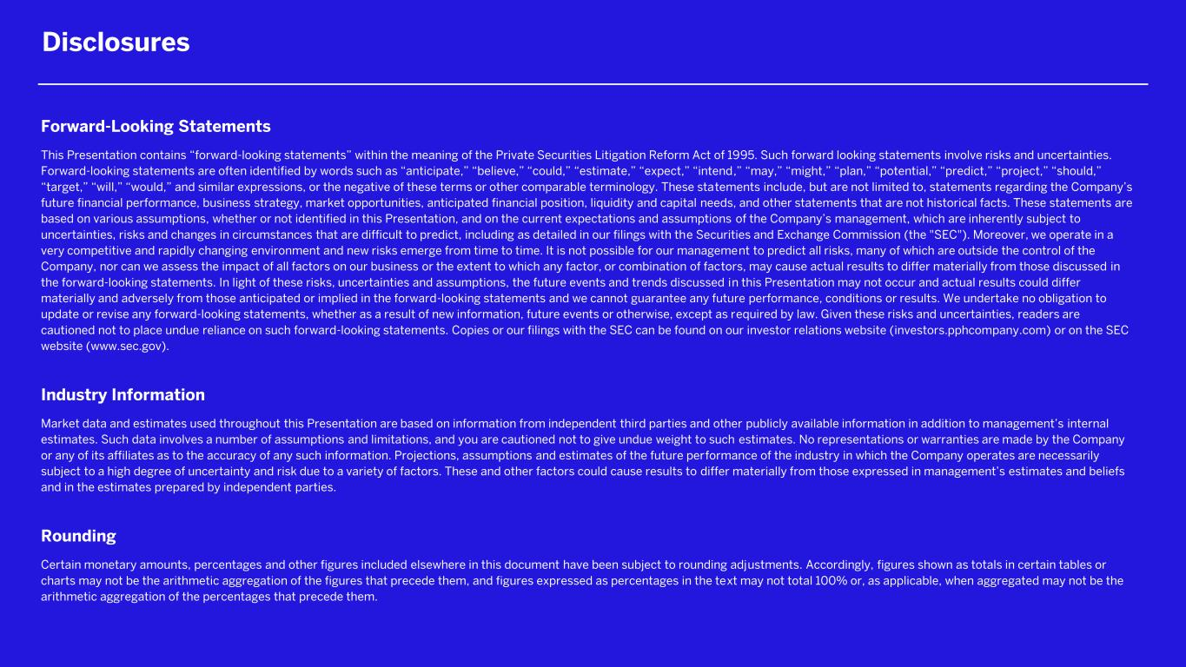
2 Forward-Looking Statements This Presentation contains “forward-looking statements” within the meaning of the Private Securities Litigation Reform Act of 1995. Such forward looking statements involve risks and uncertainties. Forward-looking statements are often identified by words such as “anticipate,” “believe,” “could,” “estimate,” “expect,” “intend,” “may,” “might,” “plan,” “potential,” “predict,” “project,” “should,” “target,” “will,” “would,” and similar expressions, or the negative of these terms or other comparable terminology. These statements include, but are not limited to, statements regarding the Company’s future financial performance, business strategy, market opportunities, anticipated financial position, liquidity and capital needs, and other statements that are not historical facts. These statements are based on various assumptions, whether or not identified in this Presentation, and on the current expectations and assumptions of the Company’s management, which are inherently subject to uncertainties, risks and changes in circumstances that are difficult to predict, including as detailed in our filings with the Securities and Exchange Commission (the "SEC"). Moreover, we operate in a very competitive and rapidly changing environment and new risks emerge from time to time. It is not possible for our management to predict all risks, many of which are outside the control of the Company, nor can we assess the impact of all factors on our business or the extent to which any factor, or combination of factors, may cause actual results to differ materially from those discussed in the forward-looking statements. In light of these risks, uncertainties and assumptions, the future events and trends discussed in this Presentation may not occur and actual results could differ materially and adversely from those anticipated or implied in the forward-looking statements and we cannot guarantee any future performance, conditions or results. We undertake no obligation to update or revise any forward-looking statements, whether as a result of new information, future events or otherwise, except as required by law. Given these risks and uncertainties, readers are cautioned not to place undue reliance on such forward-looking statements. Copies or our filings with the SEC can be found on our investor relations website (investors.pphcompany.com) or on the SEC website (www.sec.gov). Industry Information Market data and estimates used throughout this Presentation are based on information from independent third parties and other publicly available information in addition to management’s internal estimates. Such data involves a number of assumptions and limitations, and you are cautioned not to give undue weight to such estimates. No representations or warranties are made by the Company or any of its affiliates as to the accuracy of any such information. Projections, assumptions and estimates of the future performance of the industry in which the Company operates are necessarily subject to a high degree of uncertainty and risk due to a variety of factors. These and other factors could cause results to differ materially from those expressed in management’s estimates and beliefs and in the estimates prepared by independent parties. Rounding Certain monetary amounts, percentages and other figures included elsewhere in this document have been subject to rounding adjustments. Accordingly, figures shown as totals in certain tables or charts may not be the arithmetic aggregation of the figures that precede them, and figures expressed as percentages in the text may not total 100% or, as applicable, when aggregated may not be the arithmetic aggregation of the percentages that precede them. Disclosures

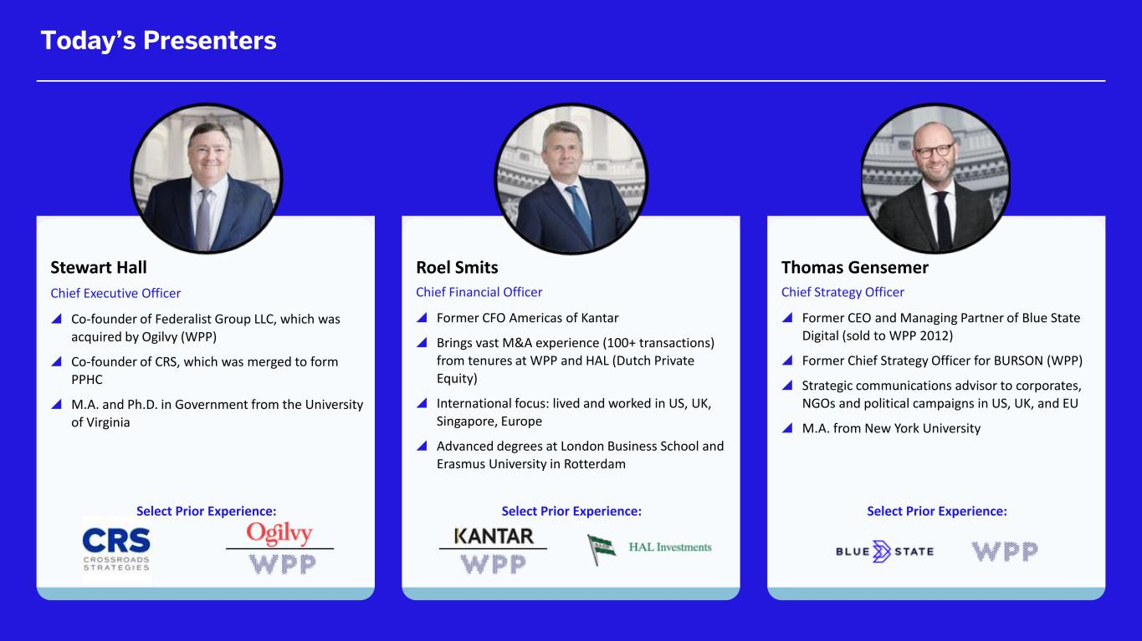
3 Stewart Hall Chief Executive Officer  Co-founder of Federalist Group LLC, which was acquired by Ogilvy (WPP)  Co-founder of CRS, which was merged to form PPHC  M.A. and Ph.D. in Government from the University of Virginia Roel Smits Chief Financial Officer  Former CFO Americas of Kantar  Brings vast M&A experience (100+ transactions) from tenures at WPP and HAL (Dutch Private Equity)  International focus: lived and worked in US, UK, Singapore, Europe  Advanced degrees at London Business School and Erasmus University in Rotterdam Thomas Gensemer Chief Strategy Officer  Former CEO and Managing Partner of Blue State Digital (sold to WPP 2012)  Former Chief Strategy Officer for BURSON (WPP)  Strategic communications advisor to corporates, NGOs and political campaigns in US, UK, and EU  M.A. from New York University Select Prior Experience: Select Prior Experience: Select Prior Experience: Today’s Presenters

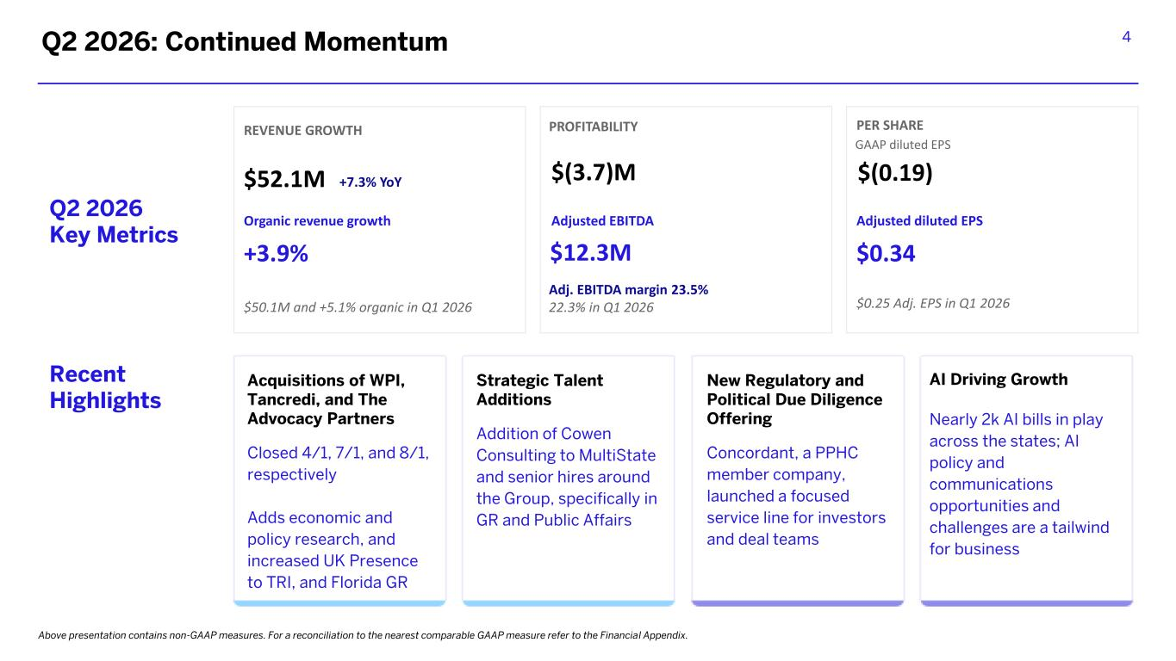
4Q2 2026: Continued Momentum Above presentation contains non-GAAP measures. For a reconciliation to the nearest comparable GAAP measure refer to the Financial Appendix. Q2 2026 Key Metrics Recent Highlights Acquisitions of WPI, Tancredi, and The Advocacy Partners Closed 4/1, 7/1, and 8/1, respectively Adds economic and policy research, and increased UK Presence to TRI, and Florida GR Strategic Talent Additions Addition of Cowen Consulting to MultiState and senior hires around the Group, specifically in GR and Public Affairs New Regulatory and Political Due Diligence Offering Concordant, a PPHC member company, launched a focused service line for investors and deal teams REVENUE GROWTH $52.1M +7.3% YoY $50.1M and +5.1% organic in Q1 2026 PROFITABILITY $(3.7)M Adjusted EBITDA $12.3M Adj. EBITDA margin 23.5% 22.3% in Q1 2026 PER SHARE GAAP diluted EPS $(0.19) Adjusted diluted EPS $0.34 $0.25 Adj. EPS in Q1 2026 Organic revenue growth +3.9% AI Driving Growth Nearly 2k AI bills in play across the states; AI policy and communications opportunities and challenges are a tailwind for business

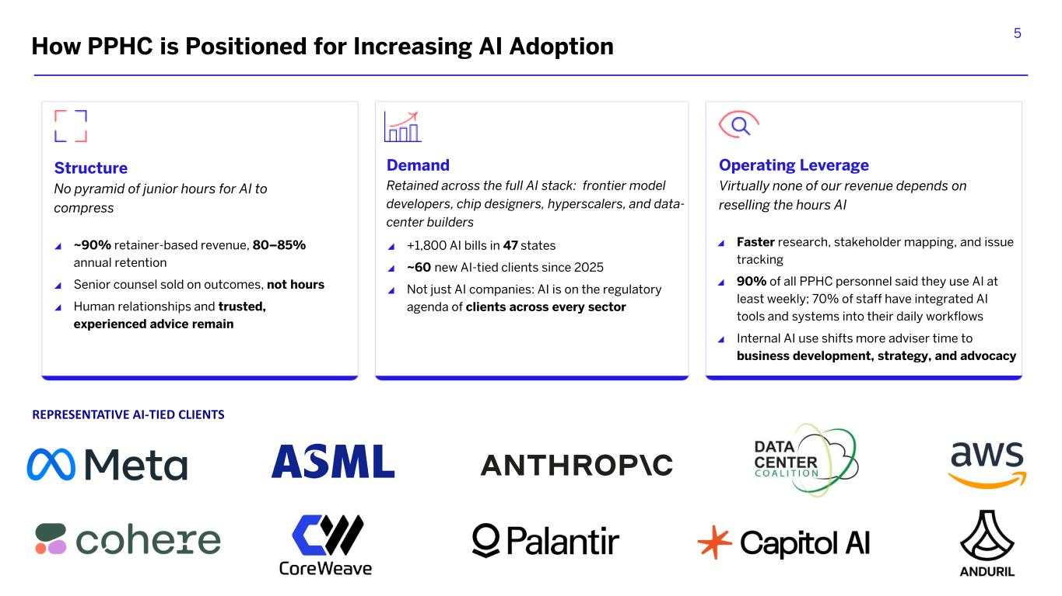
5 Structure No pyramid of junior hours for AI to compress Demand Retained across the full AI stack: frontier model developers, chip designers, hyperscalers, and data- center builders Faster research, stakeholder mapping, and issue tracking 90% of all PPHC personnel said they use AI at least weekly; 70% of staff have integrated AI tools and systems into their daily workflows Internal AI use shifts more adviser time to business development, strategy, and advocacy ~90% retainer-based revenue, 80–85% annual retention Senior counsel sold on outcomes, not hours Human relationships and trusted, experienced advice remain +1,800 AI bills in 47 states ~60 new AI-tied clients since 2025 Not just AI companies: AI is on the regulatory agenda of clients across every sector Operating Leverage Virtually none of our revenue depends on reselling the hours AI REPRESENTATIVE AI-TIED CLIENTS How PPHC is Positioned for Increasing AI Adoption


6 Financial Summary

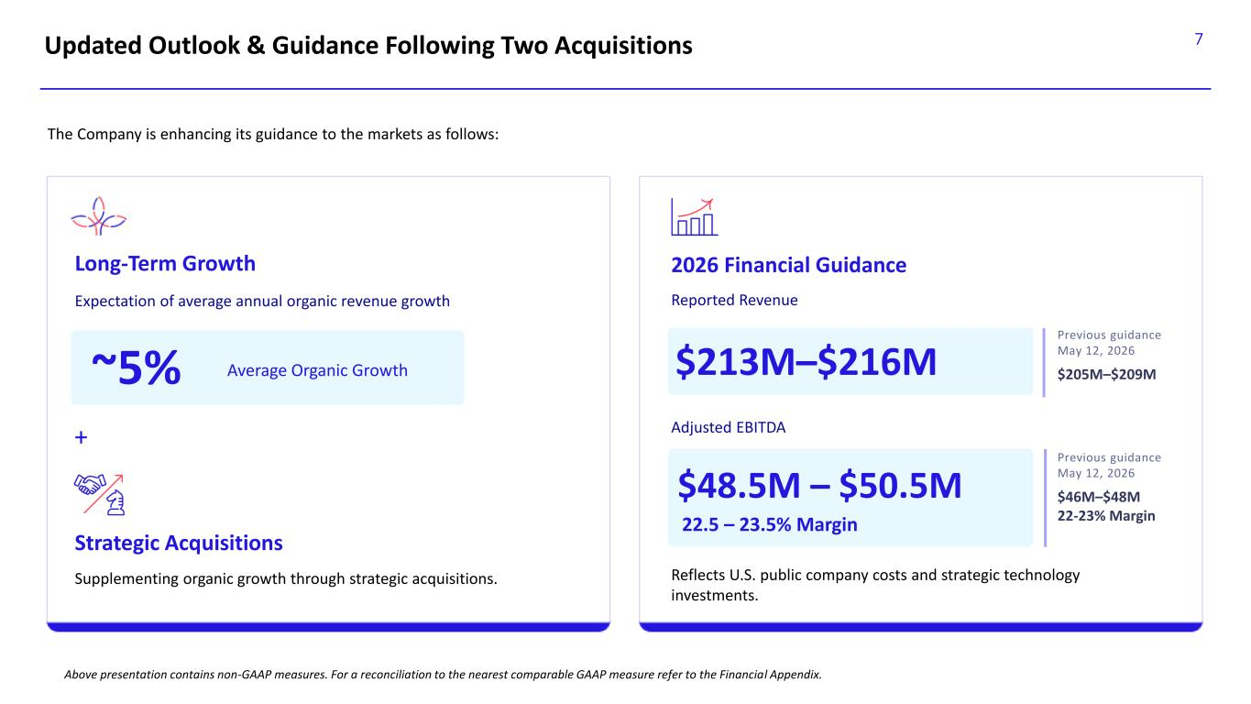
7 Above presentation contains non-GAAP measures. For a reconciliation to the nearest comparable GAAP measure refer to the Financial Appendix. Updated Outlook & Guidance Following Two Acquisitions Long-Term Growth The Company is enhancing its guidance to the markets as follows: 2026 Financial Guidance ~5% Average Organic Growth + $213M–$216M Expectation of average annual organic revenue growth Reported Revenue Supplementing organic growth through strategic acquisitions. Strategic Acquisitions Adjusted EBITDA $48.5M – $50.5M 22.5 – 23.5% Margin Reflects U.S. public company costs and strategic technology investments. Previous guidance May 12, 2026 $205M–$209M Previous guidance May 12, 2026 $46M–$48M 22-23% Margin

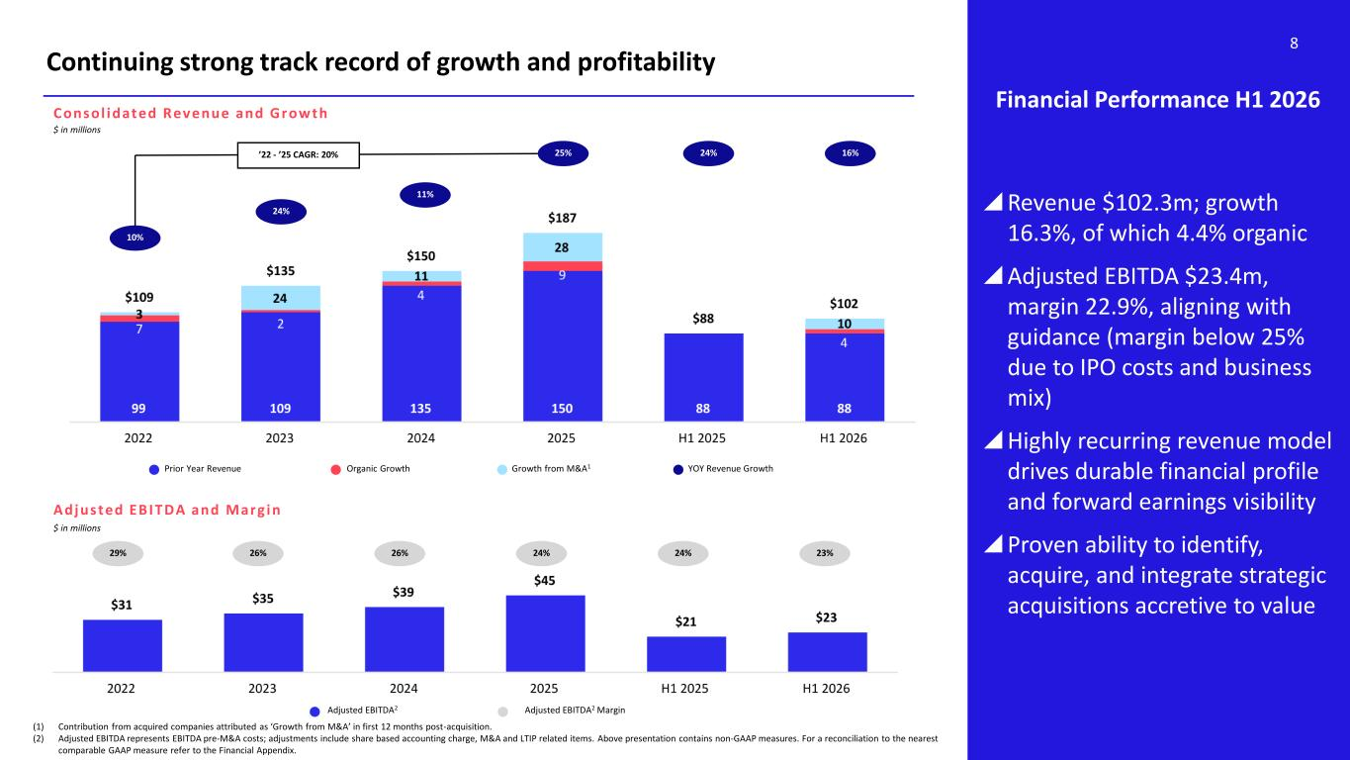
8 Continuing strong track record of growth and profitability Financial Performance H1 2026 Revenue $102.3m; growth 16.3%, of which 4.4% organic ​ Adjusted EBITDA $23.4m, margin 22.9%​, aligning with guidance (margin below 25% due to IPO costs and business mix) Highly recurring revenue model drives durable financial profile and forward earnings visibility Proven ability to identify, acquire, and integrate strategic acquisitions accretive to value ’22 - ’25 CAGR: 20% Adjusted EBITDA2 Adjusted EBITDA2 Margin 29% 26% 10% $ in millions Consol idated Revenue and Growth (1) Contribution from acquired companies attributed as ‘Growth from M&A’ in first 12 months post-acquisition. (2) Adjusted EBITDA represents EBITDA pre-M&A costs; adjustments include share based accounting charge, M&A and LTIP related items. Above presentation contains non-GAAP measures. For a reconciliation to the nearest comparable GAAP measure refer to the Financial Appendix. 24% Prior Year Revenue Organic Growth Growth from M&A1 YOY Revenue Growth Adj usted EBITDA and Marg in $ in millions 25% 26% 24% 11% 24% 23% 24% 16%

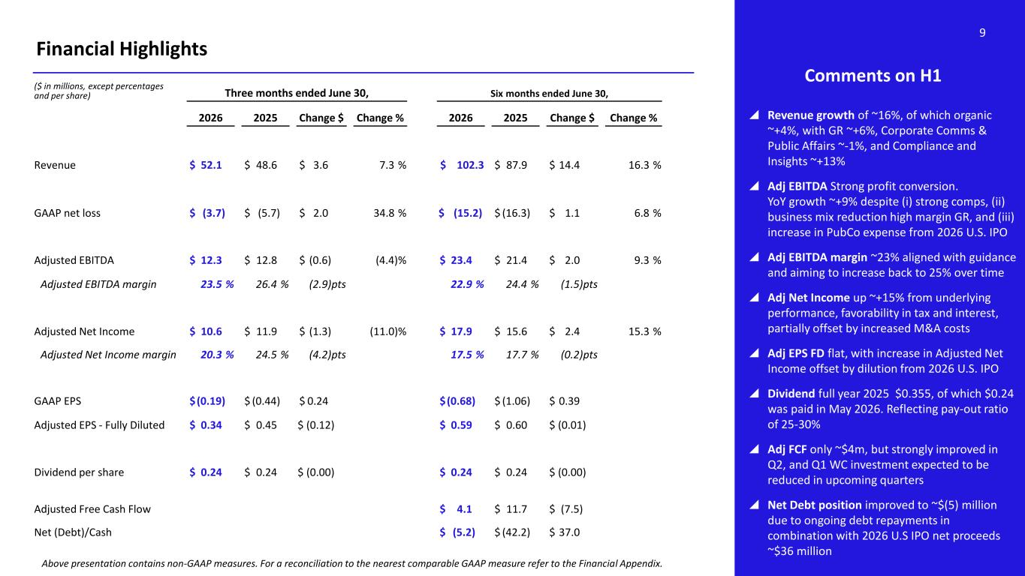
9 Financial Highlights ($ in millions, except percentages and per share) Three months ended June 30, Six months ended June 30, 2026 2025 Change $ Change % 2026 2025 Change $ Change % Revenue $ 52.1 $ 48.6 $ 3.6 7.3 % $ 102.3 $ 87.9 $ 14.4 16.3 % GAAP net loss $ (3.7) $ (5.7) $ 2.0 34.8 % $ (15.2) $ (16.3) $ 1.1 6.8 % Adjusted EBITDA $ 12.3 $ 12.8 $ (0.6) (4.4)% $ 23.4 $ 21.4 $ 2.0 9.3 % Adjusted EBITDA margin 23.5 % 26.4 % (2.9)pts 22.9 % 24.4 % (1.5)pts Adjusted Net Income $ 10.6 $ 11.9 $ (1.3) (11.0)% $ 17.9 $ 15.6 $ 2.4 15.3 % Adjusted Net Income margin 20.3 % 24.5 % (4.2)pts 17.5 % 17.7 % (0.2)pts GAAP EPS $(0.19) $ (0.44) $ 0.24 $(0.68) $ (1.06) $ 0.39 Adjusted EPS - Fully Diluted $ 0.34 $ 0.45 $ (0.12) $ 0.59 $ 0.60 $ (0.01) Dividend per share $ 0.24 $ 0.24 $ (0.00) $ 0.24 $ 0.24 $ (0.00) Adjusted Free Cash Flow $ 4.1 $ 11.7 $ (7.5) Net (Debt)/Cash $ (5.2) $ (42.2) $ 37.0 Comments on H1  Revenue growth of ~16%, of which organic ~+4%, with GR ~+6%, Corporate Comms & Public Affairs ~-1%, and Compliance and Insights ~+13%  Adj EBITDA Strong profit conversion. YoY growth ~+9% despite (i) strong comps, (ii) business mix reduction high margin GR, and (iii) increase in PubCo expense from 2026 U.S. IPO  Adj EBITDA margin ~23% aligned with guidance and aiming to increase back to 25% over time  Adj Net Income up ~+15% from underlying performance, favorability in tax and interest, partially offset by increased M&A costs  Adj EPS FD flat, with increase in Adjusted Net Income offset by dilution from 2026 U.S. IPO  Dividend full year 2025 $0.355, of which $0.24 was paid in May 2026. Reflecting pay-out ratio of 25-30%  Adj FCF only ~$4m, but strongly improved in Q2, and Q1 WC investment expected to be reduced in upcoming quarters  Net Debt position improved to ~$(5) million due to ongoing debt repayments in combination with 2026 U.S IPO net proceeds ~$36 million Above presentation contains non-GAAP measures. For a reconciliation to the nearest comparable GAAP measure refer to the Financial Appendix.

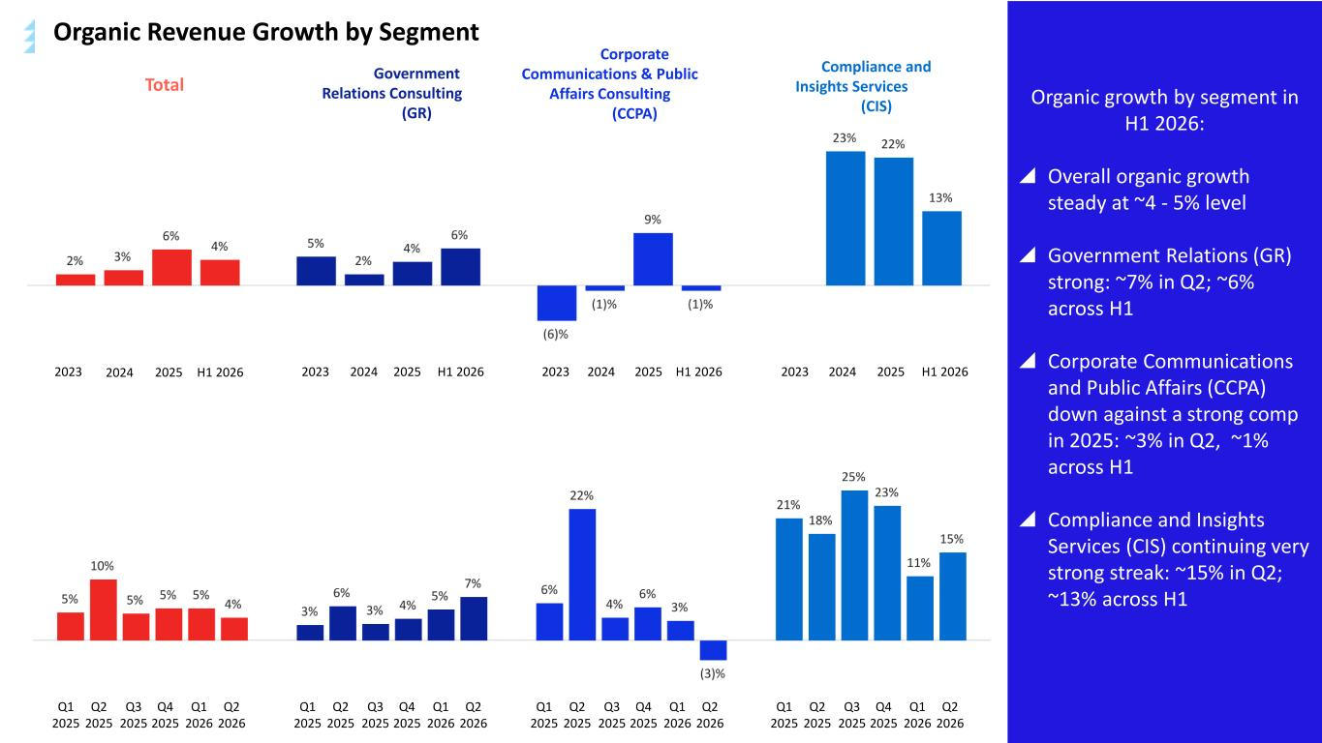
10 Organic growth by segment in H1 2026:  Overall organic growth steady at ~4 - 5% level  Government Relations (GR) strong: ~7% in Q2; ~6% across H1  Corporate Communications and Public Affairs (CCPA) down against a strong comp in 2025: ~3% in Q2, ~1% across H1  Compliance and Insights Services (CIS) continuing very strong streak: ~15% in Q2; ~13% across H1 Total 2023 2024 2025 H1 2026 Government Relations Consulting (GR) Corporate Communications & Public Affairs Consulting (CCPA) Compliance and Insights Services (CIS) 2023 2024 2025 H1 20262023 2024 2025 H1 20262023 2024 2025 H1 2026 Q1 2025 Q2 2025 Q3 2025 Q4 2025 Q1 2026 Q2 2026 Q1 2025 Q2 2025 Q3 2025 Q4 2025 Q1 2026 Q2 2026 Q1 2025 Q2 2025 Q3 2025 Q4 2025 Q1 2026 Q2 2026 Q1 2025 Q2 2025 Q3 2025 Q4 2025 Q1 2026 Q2 2026 Organic Revenue Growth by Segment

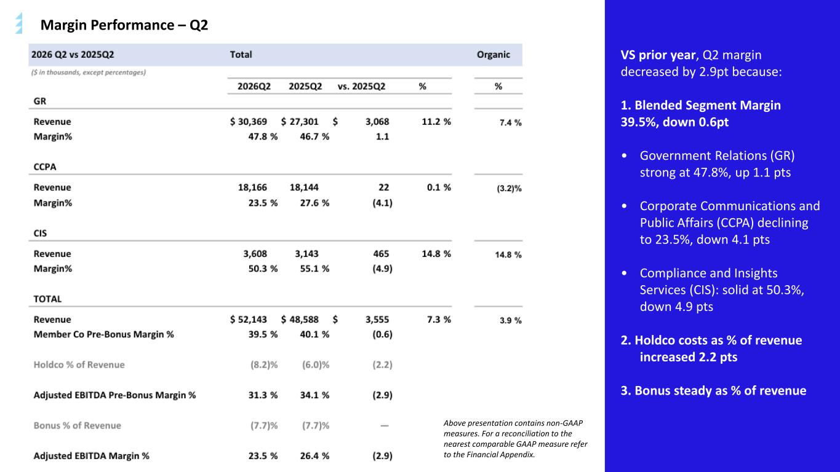
11Margin Performance – Q2 VS prior year, Q2 margin decreased by 2.9pt because: 1. Blended Segment Margin 39.5%, down 0.6pt • Government Relations (GR) strong at 47.8%, up 1.1 pts • Corporate Communications and Public Affairs (CCPA) declining to 23.5%, down 4.1 pts • Compliance and Insights Services (CIS): solid at 50.3%, down 4.9 pts 2. Holdco costs as % of revenue increased 2.2 pts 3. Bonus steady as % of revenue Above presentation contains non-GAAP measures. For a reconciliation to the nearest comparable GAAP measure refer to the Financial Appendix.

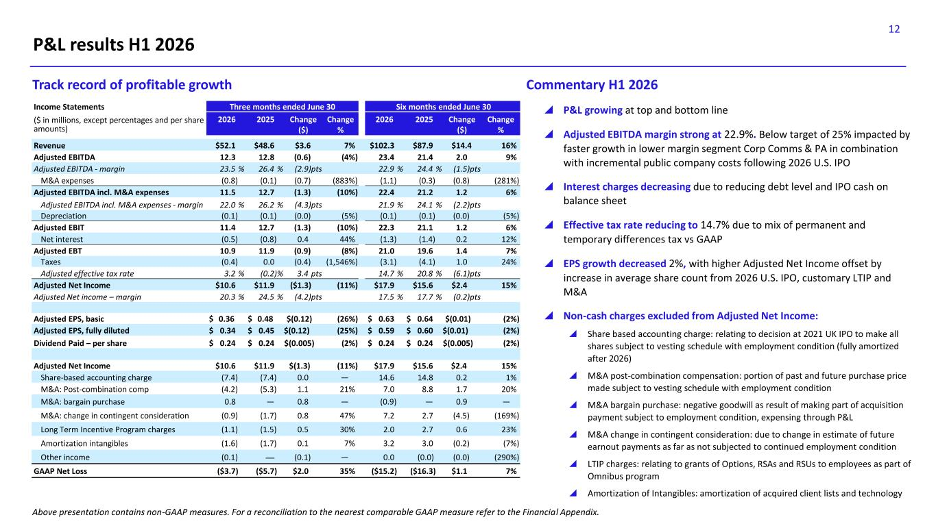
12 P&L results H1 2026  P&L growing at top and bottom line  Adjusted EBITDA margin strong at 22.9%. Below target of 25% impacted by faster growth in lower margin segment Corp Comms & PA in combination with incremental public company costs following 2026 U.S. IPO  Interest charges decreasing due to reducing debt level and IPO cash on balance sheet  Effective tax rate reducing to 14.7% due to mix of permanent and temporary differences tax vs GAAP  EPS growth decreased 2%, with higher Adjusted Net Income offset by increase in average share count from 2026 U.S. IPO, customary LTIP and M&A  Non-cash charges excluded from Adjusted Net Income:  Share based accounting charge: relating to decision at 2021 UK IPO to make all shares subject to vesting schedule with employment condition (fully amortized after 2026)  M&A post-combination compensation: portion of past and future purchase price made subject to vesting schedule with employment condition  M&A bargain purchase: negative goodwill as result of making part of acquisition payment subject to employment condition, expensing through P&L  M&A change in contingent consideration: due to change in estimate of future earnout payments as far as not subjected to continued employment condition  LTIP charges: relating to grants of Options, RSAs and RSUs to employees as part of Omnibus program  Amortization of Intangibles: amortization of acquired client lists and technology Commentary H1 2026Track record of profitable growth Income Statements Three months ended June 30 Six months ended June 30 ($ in millions, except percentages and per share amounts) 2026 2025 Change ($) Change % 2026 2025 Change ($) Change % Revenue $52.1 $48.6 $3.6 7% $102.3 $87.9 $14.4 16% Adjusted EBITDA 12.3 12.8 (0.6) (4%) 23.4 21.4 2.0 9% Adjusted EBITDA - margin 23.5 % 26.4 % (2.9)pts 22.9 % 24.4 % (1.5)pts M&A expenses (0.8) (0.1) (0.7) (883%) (1.1) (0.3) (0.8) (281%) Adjusted EBITDA incl. M&A expenses 11.5 12.7 (1.3) (10%) 22.4 21.2 1.2 6% Adjusted EBITDA incl. M&A expenses - margin 22.0 % 26.2 % (4.3)pts 21.9 % 24.1 % (2.2)pts Depreciation (0.1) (0.1) (0.0) (5%) (0.1) (0.1) (0.0) (5%) Adjusted EBIT 11.4 12.7 (1.3) (10%) 22.3 21.1 1.2 6% Net interest (0.5) (0.8) 0.4 44% (1.3) (1.4) 0.2 12% Adjusted EBT 10.9 11.9 (0.9) (8%) 21.0 19.6 1.4 7% Taxes (0.4) 0.0 (0.4) (1,546%) (3.1) (4.1) 1.0 24% Adjusted effective tax rate 3.2 % (0.2)% 3.4 pts 14.7 % 20.8 % (6.1)pts Adjusted Net Income $10.6 $11.9 ($1.3) (11%) $17.9 $15.6 $2.4 15% Adjusted Net income – margin 20.3 % 24.5 % (4.2)pts 17.5 % 17.7 % (0.2)pts Adjusted EPS, basic $ 0.36 $ 0.48 $(0.12) (26%) $ 0.63 $ 0.64 $(0.01) (2%) Adjusted EPS, fully diluted $ 0.34 $ 0.45 $(0.12) (25%) $ 0.59 $ 0.60 $(0.01) (2%) Dividend Paid – per share $ 0.24 $ 0.24 $(0.005) (2%) $ 0.24 $ 0.24 $(0.005) (2%) Adjusted Net Income $10.6 $11.9 $(1.3) (11%) $17.9 $15.6 $2.4 15% Share-based accounting charge (7.4) (7.4) 0.0 — 14.6 14.8 0.2 1% M&A: Post-combination comp (4.2) (5.3) 1.1 21% 7.0 8.8 1.7 20% M&A: bargain purchase 0.8 — 0.8 — (0.9) — 0.9 — M&A: change in contingent consideration (0.9) (1.7) 0.8 47% 7.2 2.7 (4.5) (169%) Long Term Incentive Program charges (1.1) (1.5) 0.5 30% 2.0 2.7 0.6 23% Amortization intangibles (1.6) (1.7) 0.1 7% 3.2 3.0 (0.2) (7%) Other income (0.1) — (0.1) — 0.0 (0.0) (0.0) (290%) GAAP Net Loss ($3.7) ($5.7) $2.0 35% ($15.2) ($16.3) $1.1 7% Above presentation contains non-GAAP measures. For a reconciliation to the nearest comparable GAAP measure refer to the Financial Appendix.

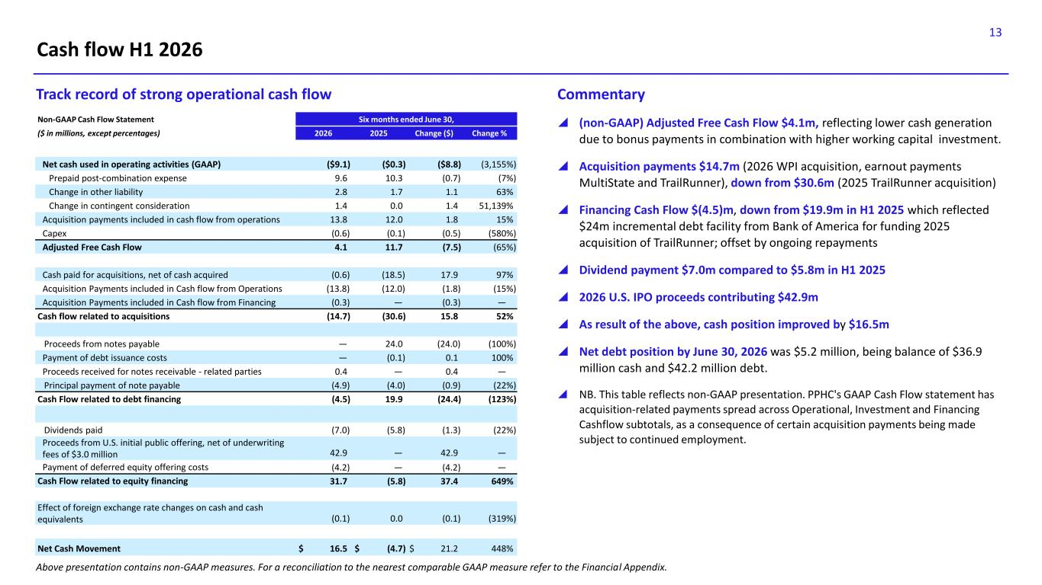
13 Cash flow H1 2026  (non-GAAP) Adjusted Free Cash Flow $4.1m, reflecting lower cash generation due to bonus payments in combination with higher working capital investment.  Acquisition payments $14.7m (2026 WPI acquisition, earnout payments MultiState and TrailRunner), down from $30.6m (2025 TrailRunner acquisition)  Financing Cash Flow $(4.5)m, down from $19.9m in H1 2025 which reflected $24m incremental debt facility from Bank of America for funding 2025 acquisition of TrailRunner; offset by ongoing repayments  Dividend payment $7.0m compared to $5.8m in H1 2025  2026 U.S. IPO proceeds contributing $42.9m  As result of the above, cash position improved by $16.5m  Net debt position by June 30, 2026 was $5.2 million, being balance of $36.9 million cash and $42.2 million debt.  NB. This table reflects non-GAAP presentation. PPHC's GAAP Cash Flow statement has acquisition-related payments spread across Operational, Investment and Financing Cashflow subtotals, as a consequence of certain acquisition payments being made subject to continued employment. Track record of strong operational cash flow Commentary Non-GAAP Cash Flow Statement Six months ended June 30, ($ in millions, except percentages) 2026 2025 Change ($) Change % Net cash used in operating activities (GAAP) ($9.1) ($0.3) ($8.8) (3,155%) Prepaid post-combination expense 9.6 10.3 (0.7) (7%) Change in other liability 2.8 1.7 1.1 63% Change in contingent consideration 1.4 0.0 1.4 51,139% Acquisition payments included in cash flow from operations 13.8 12.0 1.8 15% Capex (0.6) (0.1) (0.5) (580%) Adjusted Free Cash Flow 4.1 11.7 (7.5) (65%) Cash paid for acquisitions, net of cash acquired (0.6) (18.5) 17.9 97% Acquisition Payments included in Cash flow from Operations (13.8) (12.0) (1.8) (15%) Acquisition Payments included in Cash flow from Financing (0.3) — (0.3) — Cash flow related to acquisitions (14.7) (30.6) 15.8 52% Proceeds from notes payable — 24.0 (24.0) (100%) Payment of debt issuance costs — (0.1) 0.1 100% Proceeds received for notes receivable - related parties 0.4 — 0.4 — Principal payment of note payable (4.9) (4.0) (0.9) (22%) Cash Flow related to debt financing (4.5) 19.9 (24.4) (123%) Dividends paid (7.0) (5.8) (1.3) (22%) Proceeds from U.S. initial public offering, net of underwriting fees of $3.0 million 42.9 — 42.9 — Payment of deferred equity offering costs (4.2) — (4.2) — Cash Flow related to equity financing 31.7 (5.8) 37.4 649% Effect of foreign exchange rate changes on cash and cash equivalents (0.1) 0.0 (0.1) (319%) Net Cash Movement $ 16.5 $ (4.7) $ 21.2 448% Above presentation contains non-GAAP measures. For a reconciliation to the nearest comparable GAAP measure refer to the Financial Appendix.

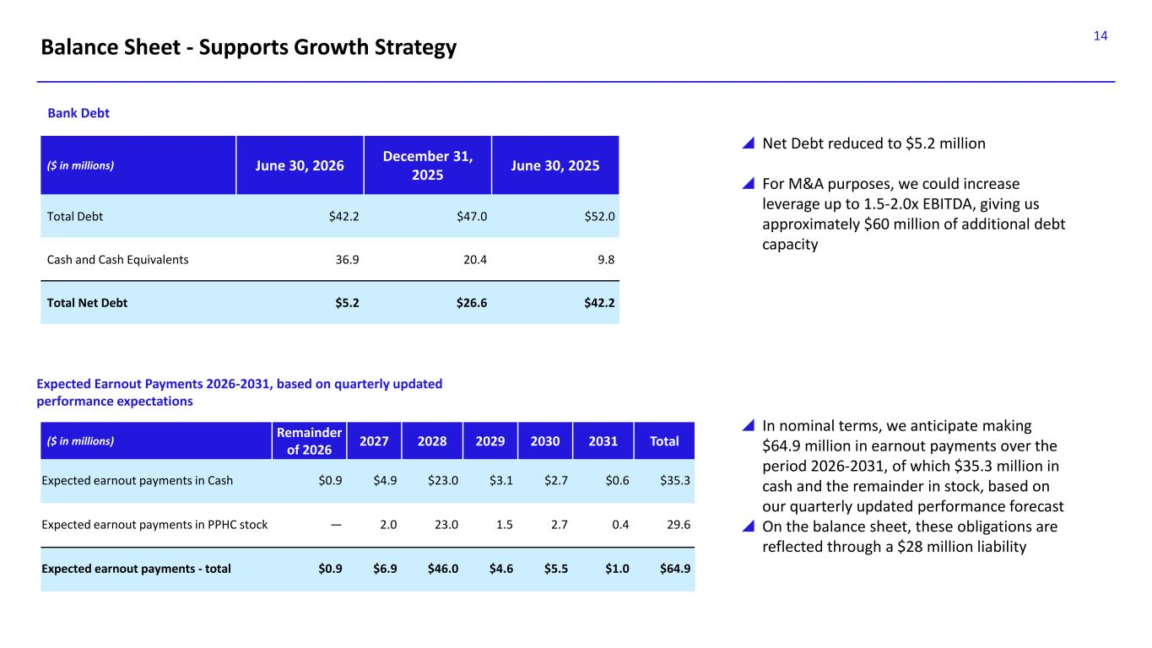
14 Balance Sheet - Supports Growth Strategy ($ in millions) June 30, 2026 December 31, 2025 June 30, 2025 Total Debt $42.2 $47.0 $52.0 Cash and Cash Equivalents 36.9 20.4 9.8 Total Net Debt $5.2 $26.6 $42.2  Net Debt reduced to $5.2 million  For M&A purposes, we could increase leverage up to 1.5-2.0x EBITDA, giving us approximately $60 million of additional debt capacity  In nominal terms, we anticipate making $64.9 million in earnout payments over the period 2026-2031, of which $35.3 million in cash and the remainder in stock, based on our quarterly updated performance forecast  On the balance sheet, these obligations are reflected through a $28 million liability Expected Earnout Payments 2026-2031, based on quarterly updated performance expectations Bank Debt ($ in millions) Remainder of 2026 2027 2028 2029 2030 2031 Total Expected earnout payments in Cash $0.9 $4.9 $23.0 $3.1 $2.7 $0.6 $35.3 Expected earnout payments in PPHC stock — 2.0 23.0 1.5 2.7 0.4 29.6 Expected earnout payments - total $0.9 $6.9 $46.0 $4.6 $5.5 $1.0 $64.9

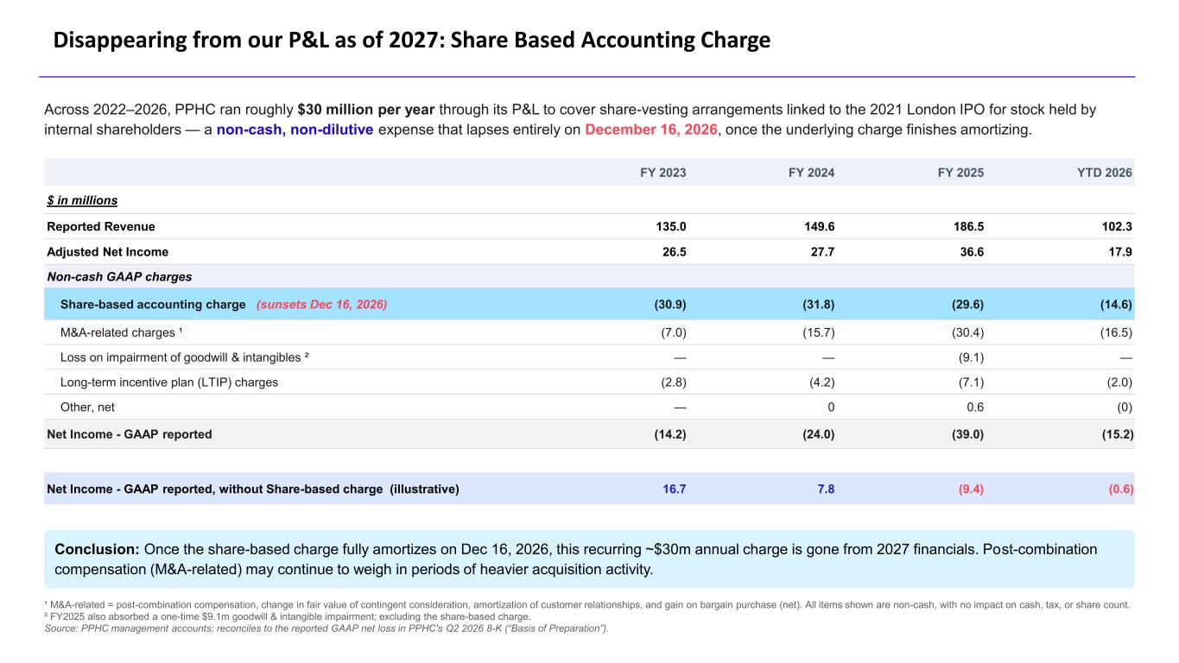
Across 2022–2026, PPHC ran roughly $30 million per year through its P&L to cover share-vesting arrangements linked to the 2021 London IPO for stock held by internal shareholders — a non-cash, non-dilutive expense that lapses entirely on December 16, 2026, once the underlying charge finishes amortizing. FY 2023 FY 2024 FY 2025 YTD 2026 $ in millions Reported Revenue 135.0 149.6 186.5 102.3 Adjusted Net Income 26.5 27.7 36.6 17.9 Non-cash GAAP charges Share-based accounting charge (sunsets Dec 16, 2026) (30.9) (31.8) (29.6) (14.6) M&A-related charges ¹ (7.0) (15.7) (30.4) (16.5) Loss on impairment of goodwill & intangibles ² — — (9.1) — Long-term incentive plan (LTIP) charges (2.8) (4.2) (7.1) (2.0) Other, net — 0 0.6 (0) Net Income - GAAP reported (14.2) (24.0) (39.0) (15.2) Net Income - GAAP reported, without Share-based charge (illustrative) 16.7 7.8 (9.4) (0.6) Conclusion: Once the share-based charge fully amortizes on Dec 16, 2026, this recurring ~$30m annual charge is gone from 2027 financials. Post-combination compensation (M&A-related) may continue to weigh in periods of heavier acquisition activity. ¹ M&A-related = post-combination compensation, change in fair value of contingent consideration, amortization of customer relationships, and gain on bargain purchase (net). All items shown are non-cash, with no impact on cash, tax, or share count. ² FY2025 also absorbed a one-time $9.1m goodwill & intangible impairment; excluding the share-based charge. Source: PPHC management accounts; reconciles to the reported GAAP net loss in PPHC's Q2 2026 8-K (“Basis of Preparation”). Disappearing from our P&L as of 2027: Share Based Accounting Charge


16 Strategy and M&A

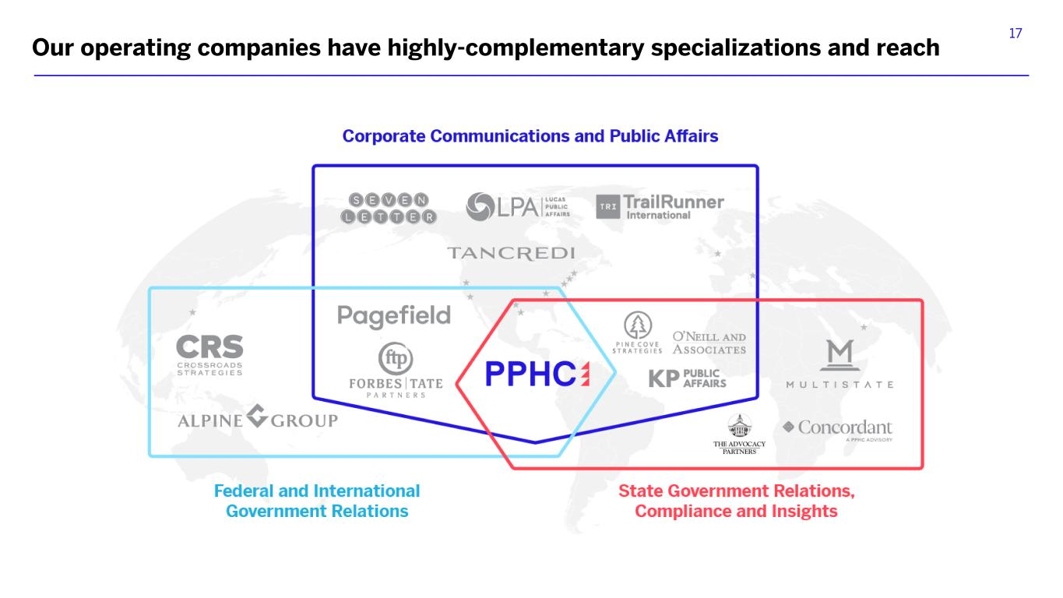
17 Our operating companies have highly-complementary specializations and reach

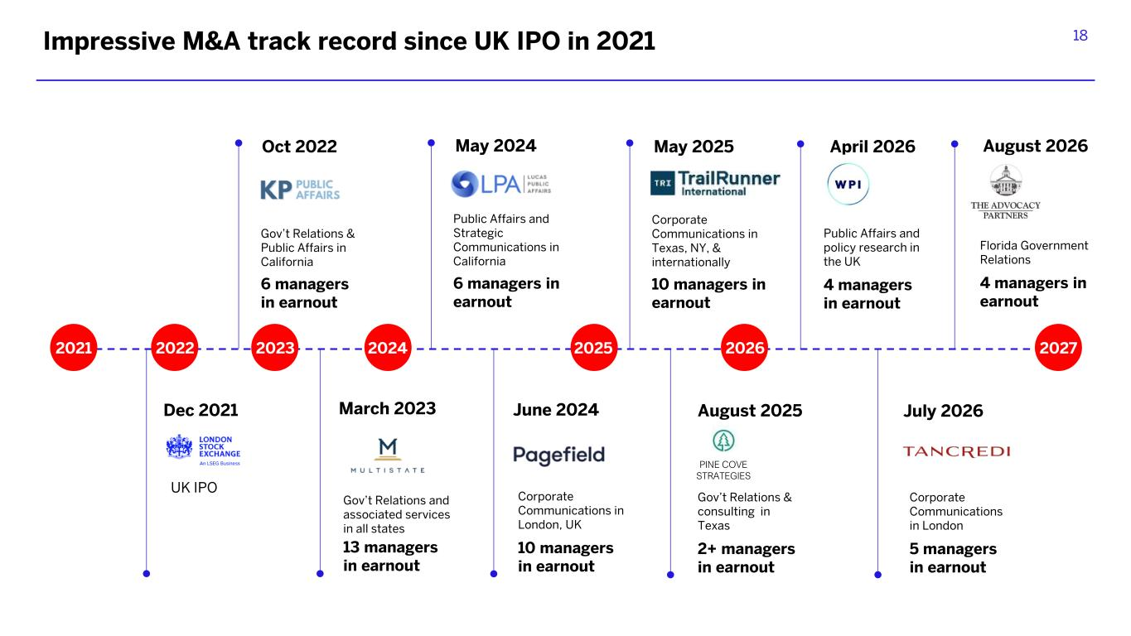
18 2021 2022 2023 2025 2026 2027 Oct 2022 Gov’t Relations & Public Affairs in California 6 managers in earnout Gov’t Relations and associated services in all states 13 managers in earnout March 2023 May 2024 Public Affairs and Strategic Communications in California 6 managers in earnout 2024 Corporate Communications in London, UK 10 managers in earnout June 2024 May 2025 Corporate Communications in Texas, NY, & internationally 10 managers in earnout Gov’t Relations & consulting in Texas 2+ managers in earnout August 2025 July 2026 Corporate Communications 5 managers in earnout Impressive M&A track record since UK IPO in 2021 PINE COVE STRATEGIES July 2026 Corporate Communications in London 5 managers in earnout Apri 2026 Public Affairs nd policy research in the UK 4 managers in earnout August 2026 Florida Government Relations 4 managers in earnout Dec 2021 UK IPO

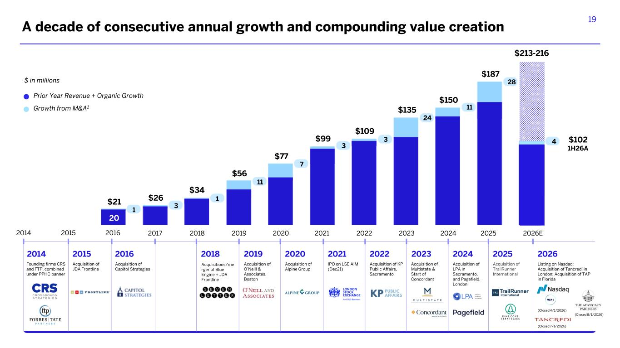
19 2014 2014 Founding firms CRS and FTP, combined under PPHC banner 2015 2016 2017 2018 2019 2020 2021 2022 2023 2024 2025 2018 Acquisitions/me rger of Blue Engine + JDA Frontline 2019 Acquisition of O’Neill & Associates, Boston 2020 Acquisition of Alpine Group 2021 IPO on LSE AIM (Dec21) 2022 Acquisition of KP Public Affairs, Sacramento 2023 Acquisition of Multistate & Start of Concordant 2024 Acquisition of LPA in Sacramento, and Pagefield, London 2025 Acquisition of TrailRunner International A decade of consecutive annual growth and compounding value creation 2015 Acquisition of JDA Frontline 2016 Acquisition of Capitol Strategies 2026E 2026 Listing on Nasdaq; Acquisition of Tancredi in London; Acquisition of TAP in Florida 1 $21 20 $26 $34 $56 $77 $99 $109 $135 $150 $187 $102 1H26A $213-216 3 1 11 7 3 3 24 11 28 4 Prior Year Revenue + Organic Growth $ in millions Growth from M&A1 (Closed 7/1/2026) (Closed 8/1/2026) (Closed 4/1/2026)


20 Conclusion

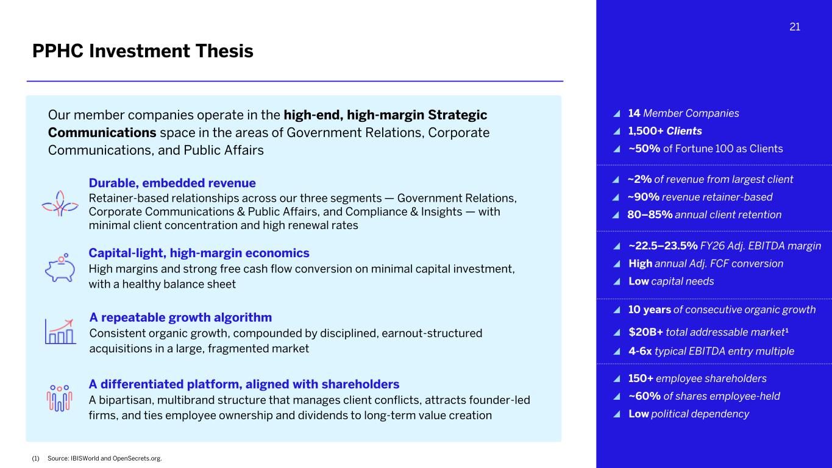
21 PPHC Investment Thesis Capital-light, high-margin economics High margins and strong free cash flow conversion on minimal capital investment, with a healthy balance sheet Durable, embedded revenue Retainer-based relationships across our three segments — Government Relations, Corporate Communications & Public Affairs, and Compliance & Insights — with minimal client concentration and high renewal rates Our member companies operate in the high-end, high-margin Strategic Communications space in the areas of Government Relations, Corporate Communications, and Public Affairs ~2% of revenue from largest client ~90% revenue retainer-based 80–85% annual client retention A differentiated platform, aligned with shareholders A bipartisan, multibrand structure that manages client conflicts, attracts founder-led firms, and ties employee ownership and dividends to long-term value creation ~22.5–23.5% FY26 Adj. EBITDA margin High annual Adj. FCF conversion Low capital needs 150+ employee shareholders ~60% of shares employee-held Low political dependency 14 Member Companies 1,500+ Clients ~50% of Fortune 100 as Clients (1) Source: IBISWorld and OpenSecrets.org. A repeatable growth algorithm Consistent organic growth, compounded by disciplined, earnout-structured acquisitions in a large, fragmented market 10 years of consecutive organic growth $20B+ total addressable market1 4-6x typical EBITDA entry multiple


22 Financial Appendix

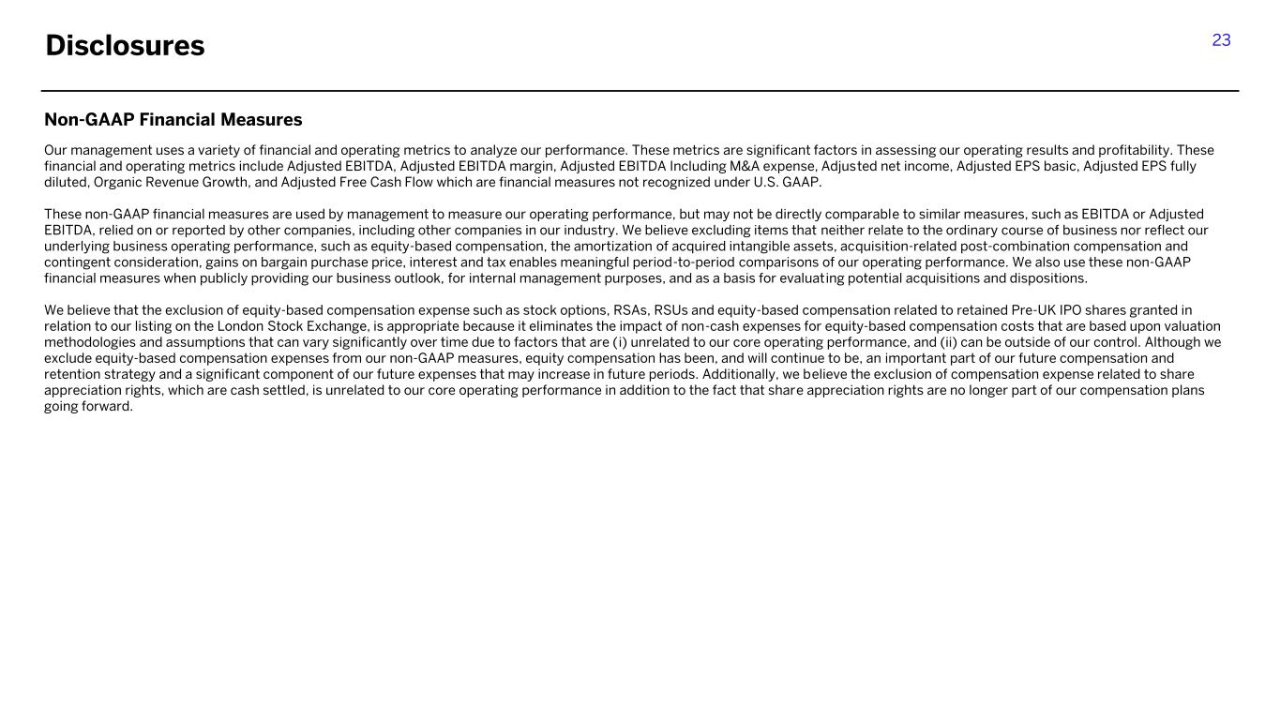
23 Non-GAAP Financial Measures Our management uses a variety of financial and operating metrics to analyze our performance. These metrics are significant factors in assessing our operating results and profitability. These financial and operating metrics include Adjusted EBITDA, Adjusted EBITDA margin, Adjusted EBITDA Including M&A expense, Adjusted net income, Adjusted EPS basic, Adjusted EPS fully diluted, Organic Revenue Growth, and Adjusted Free Cash Flow which are financial measures not recognized under U.S. GAAP. These non-GAAP financial measures are used by management to measure our operating performance, but may not be directly comparable to similar measures, such as EBITDA or Adjusted EBITDA, relied on or reported by other companies, including other companies in our industry. We believe excluding items that neither relate to the ordinary course of business nor reflect our underlying business operating performance, such as equity-based compensation, the amortization of acquired intangible assets, acquisition-related post-combination compensation and contingent consideration, gains on bargain purchase price, interest and tax enables meaningful period-to-period comparisons of our operating performance. We also use these non-GAAP financial measures when publicly providing our business outlook, for internal management purposes, and as a basis for evaluating potential acquisitions and dispositions. We believe that the exclusion of equity-based compensation expense such as stock options, RSAs, RSUs and equity-based compensation related to retained Pre-UK IPO shares granted in relation to our listing on the London Stock Exchange, is appropriate because it eliminates the impact of non-cash expenses for equity-based compensation costs that are based upon valuation methodologies and assumptions that can vary significantly over time due to factors that are (i) unrelated to our core operating performance, and (ii) can be outside of our control. Although we exclude equity-based compensation expenses from our non-GAAP measures, equity compensation has been, and will continue to be, an important part of our future compensation and retention strategy and a significant component of our future expenses that may increase in future periods. Additionally, we believe the exclusion of compensation expense related to share appreciation rights, which are cash settled, is unrelated to our core operating performance in addition to the fact that share appreciation rights are no longer part of our compensation plans going forward. Disclosures

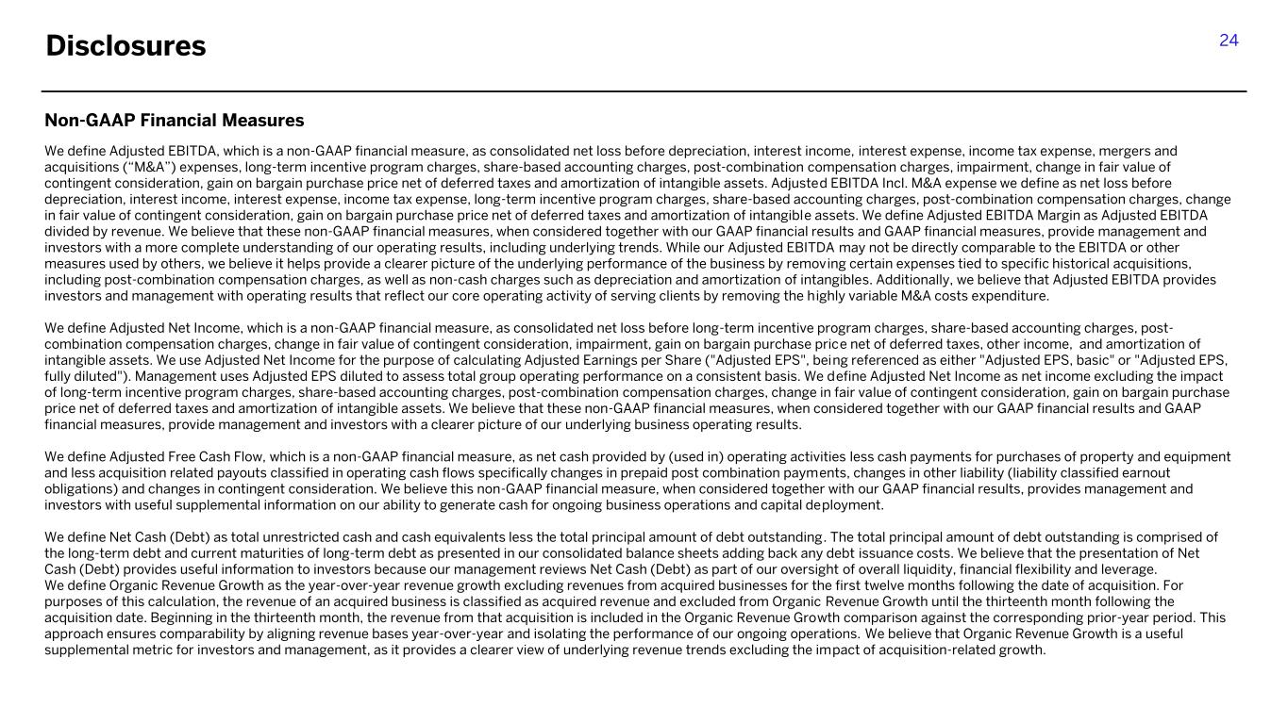
24 Non-GAAP Financial Measures We define Adjusted EBITDA, which is a non-GAAP financial measure, as consolidated net loss before depreciation, interest income, interest expense, income tax expense, mergers and acquisitions (“M&A”) expenses, long-term incentive program charges, share-based accounting charges, post-combination compensation charges, impairment, change in fair value of contingent consideration, gain on bargain purchase price net of deferred taxes and amortization of intangible assets. Adjusted EBITDA Incl. M&A expense we define as net loss before depreciation, interest income, interest expense, income tax expense, long-term incentive program charges, share-based accounting charges, post-combination compensation charges, change in fair value of contingent consideration, gain on bargain purchase price net of deferred taxes and amortization of intangible assets. We define Adjusted EBITDA Margin as Adjusted EBITDA divided by revenue. We believe that these non-GAAP financial measures, when considered together with our GAAP financial results and GAAP financial measures, provide management and investors with a more complete understanding of our operating results, including underlying trends. While our Adjusted EBITDA may not be directly comparable to the EBITDA or other measures used by others, we believe it helps provide a clearer picture of the underlying performance of the business by removing certain expenses tied to specific historical acquisitions, including post-combination compensation charges, as well as non-cash charges such as depreciation and amortization of intangibles. Additionally, we believe that Adjusted EBITDA provides investors and management with operating results that reflect our core operating activity of serving clients by removing the highly variable M&A costs expenditure. We define Adjusted Net Income, which is a non-GAAP financial measure, as consolidated net loss before long-term incentive program charges, share-based accounting charges, post- combination compensation charges, change in fair value of contingent consideration, impairment, gain on bargain purchase price net of deferred taxes, other income, and amortization of intangible assets. We use Adjusted Net Income for the purpose of calculating Adjusted Earnings per Share ("Adjusted EPS", being referenced as either "Adjusted EPS, basic" or "Adjusted EPS, fully diluted"). Management uses Adjusted EPS diluted to assess total group operating performance on a consistent basis. We define Adjusted Net Income as net income excluding the impact of long-term incentive program charges, share-based accounting charges, post-combination compensation charges, change in fair value of contingent consideration, gain on bargain purchase price net of deferred taxes and amortization of intangible assets. We believe that these non-GAAP financial measures, when considered together with our GAAP financial results and GAAP financial measures, provide management and investors with a clearer picture of our underlying business operating results. We define Adjusted Free Cash Flow, which is a non-GAAP financial measure, as net cash provided by (used in) operating activities less cash payments for purchases of property and equipment and less acquisition related payouts classified in operating cash flows specifically changes in prepaid post combination payments, changes in other liability (liability classified earnout obligations) and changes in contingent consideration. We believe this non-GAAP financial measure, when considered together with our GAAP financial results, provides management and investors with useful supplemental information on our ability to generate cash for ongoing business operations and capital deployment. We define Net Cash (Debt) as total unrestricted cash and cash equivalents less the total principal amount of debt outstanding. The total principal amount of debt outstanding is comprised of the long-term debt and current maturities of long-term debt as presented in our consolidated balance sheets adding back any debt issuance costs. We believe that the presentation of Net Cash (Debt) provides useful information to investors because our management reviews Net Cash (Debt) as part of our oversight of overall liquidity, financial flexibility and leverage. We define Organic Revenue Growth as the year-over-year revenue growth excluding revenues from acquired businesses for the first twelve months following the date of acquisition. For purposes of this calculation, the revenue of an acquired business is classified as acquired revenue and excluded from Organic Revenue Growth until the thirteenth month following the acquisition date. Beginning in the thirteenth month, the revenue from that acquisition is included in the Organic Revenue Growth comparison against the corresponding prior-year period. This approach ensures comparability by aligning revenue bases year-over-year and isolating the performance of our ongoing operations. We believe that Organic Revenue Growth is a useful supplemental metric for investors and management, as it provides a clearer view of underlying revenue trends excluding the impact of acquisition-related growth. Disclosures

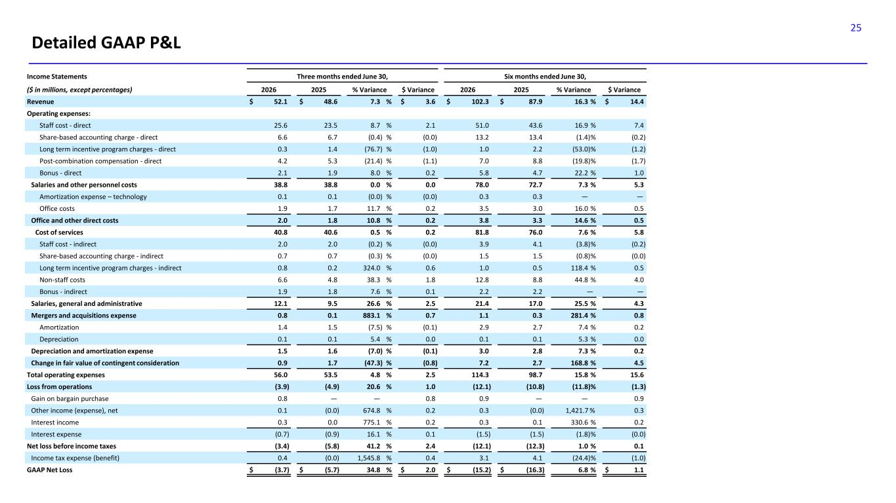
25 Detailed GAAP P&L Income Statements Three months ended June 30, Six months ended June 30, ($ in millions, except percentages) 2026 2025 % Variance $ Variance 2026 2025 % Variance $ Variance Revenue $ 52.1 $ 48.6 7.3 % $ 3.6 $ 102.3 $ 87.9 16.3 % $ 14.4 Operating expenses: Staff cost - direct 25.6 23.5 8.7 % 2.1 51.0 43.6 16.9 % 7.4 Share-based accounting charge - direct 6.6 6.7 (0.4) % (0.0) 13.2 13.4 (1.4)% (0.2) Long term incentive program charges - direct 0.3 1.4 (76.7) % (1.0) 1.0 2.2 (53.0)% (1.2) Post-combination compensation - direct 4.2 5.3 (21.4) % (1.1) 7.0 8.8 (19.8)% (1.7) Bonus - direct 2.1 1.9 8.0 % 0.2 5.8 4.7 22.2 % 1.0 Salaries and other personnel costs 38.8 38.8 0.0 % 0.0 78.0 72.7 7.3 % 5.3 Amortization expense – technology 0.1 0.1 (0.0) % (0.0) 0.3 0.3 — — Office costs 1.9 1.7 11.7 % 0.2 3.5 3.0 16.0 % 0.5 Office and other direct costs 2.0 1.8 10.8 % 0.2 3.8 3.3 14.6 % 0.5 Cost of services 40.8 40.6 0.5 % 0.2 81.8 76.0 7.6 % 5.8 Staff cost - indirect 2.0 2.0 (0.2) % (0.0) 3.9 4.1 (3.8)% (0.2) Share-based accounting charge - indirect 0.7 0.7 (0.3) % (0.0) 1.5 1.5 (0.8)% (0.0) Long term incentive program charges - indirect 0.8 0.2 324.0 % 0.6 1.0 0.5 118.4 % 0.5 Non-staff costs 6.6 4.8 38.3 % 1.8 12.8 8.8 44.8 % 4.0 Bonus - indirect 1.9 1.8 7.6 % 0.1 2.2 2.2 — — Salaries, general and administrative 12.1 9.5 26.6 % 2.5 21.4 17.0 25.5 % 4.3 Mergers and acquisitions expense 0.8 0.1 883.1 % 0.7 1.1 0.3 281.4 % 0.8 Amortization 1.4 1.5 (7.5) % (0.1) 2.9 2.7 7.4 % 0.2 Depreciation 0.1 0.1 5.4 % 0.0 0.1 0.1 5.3 % 0.0 Depreciation and amortization expense 1.5 1.6 (7.0) % (0.1) 3.0 2.8 7.3 % 0.2 Change in fair value of contingent consideration 0.9 1.7 (47.3) % (0.8) 7.2 2.7 168.8 % 4.5 Total operating expenses 56.0 53.5 4.8 % 2.5 114.3 98.7 15.8 % 15.6 Loss from operations (3.9) (4.9) 20.6 % 1.0 (12.1) (10.8) (11.8)% (1.3) Gain on bargain purchase 0.8 — — 0.8 0.9 — — 0.9 Other income (expense), net 0.1 (0.0) 674.8 % 0.2 0.3 (0.0) 1,421.7 % 0.3 Interest income 0.3 0.0 775.1 % 0.2 0.3 0.1 330.6 % 0.2 Interest expense (0.7) (0.9) 16.1 % 0.1 (1.5) (1.5) (1.8)% (0.0) Net loss before income taxes (3.4) (5.8) 41.2 % 2.4 (12.1) (12.3) 1.0 % 0.1 Income tax expense (benefit) 0.4 (0.0) 1,545.8 % 0.4 3.1 4.1 (24.4)% (1.0) GAAP Net Loss $ (3.7) $ (5.7) 34.8 % $ 2.0 $ (15.2) $ (16.3) 6.8 % $ 1.1

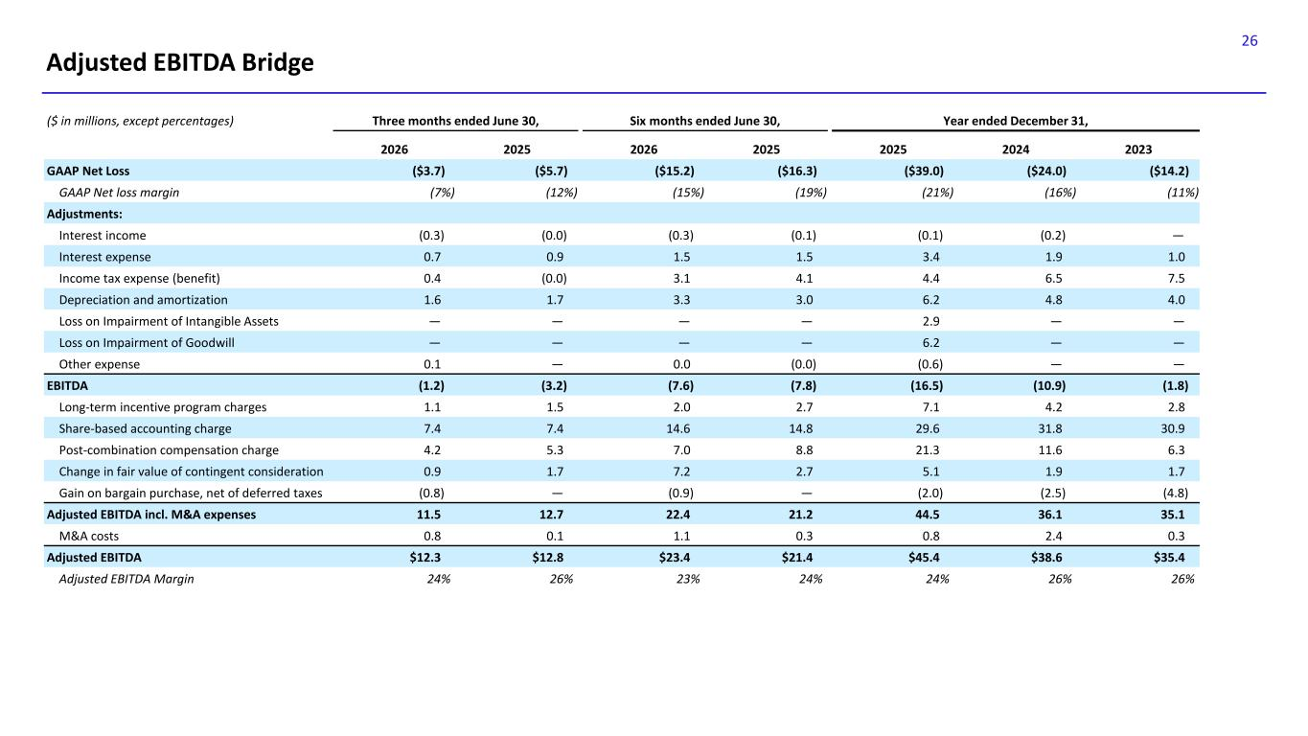
26 Adjusted EBITDA Bridge ($ in millions, except percentages) Three months ended June 30, Six months ended June 30, Year ended December 31, 2026 2025 2026 2025 2025 2024 2023 GAAP Net Loss ($3.7) ($5.7) ($15.2) ($16.3) ($39.0) ($24.0) ($14.2) GAAP Net loss margin (7%) (12%) (15%) (19%) (21%) (16%) (11%) Adjustments: Interest income (0.3) (0.0) (0.3) (0.1) (0.1) (0.2) — Interest expense 0.7 0.9 1.5 1.5 3.4 1.9 1.0 Income tax expense (benefit) 0.4 (0.0) 3.1 4.1 4.4 6.5 7.5 Depreciation and amortization 1.6 1.7 3.3 3.0 6.2 4.8 4.0 Loss on Impairment of Intangible Assets — — — — 2.9 — — Loss on Impairment of Goodwill — — — — 6.2 — — Other expense 0.1 — 0.0 (0.0) (0.6) — — EBITDA (1.2) (3.2) (7.6) (7.8) (16.5) (10.9) (1.8) Long-term incentive program charges 1.1 1.5 2.0 2.7 7.1 4.2 2.8 Share-based accounting charge 7.4 7.4 14.6 14.8 29.6 31.8 30.9 Post-combination compensation charge 4.2 5.3 7.0 8.8 21.3 11.6 6.3 Change in fair value of contingent consideration 0.9 1.7 7.2 2.7 5.1 1.9 1.7 Gain on bargain purchase, net of deferred taxes (0.8) — (0.9) — (2.0) (2.5) (4.8) Adjusted EBITDA incl. M&A expenses 11.5 12.7 22.4 21.2 44.5 36.1 35.1 M&A costs 0.8 0.1 1.1 0.3 0.8 2.4 0.3 Adjusted EBITDA $12.3 $12.8 $23.4 $21.4 $45.4 $38.6 $35.4 Adjusted EBITDA Margin 24% 26% 23% 24% 24% 26% 26%

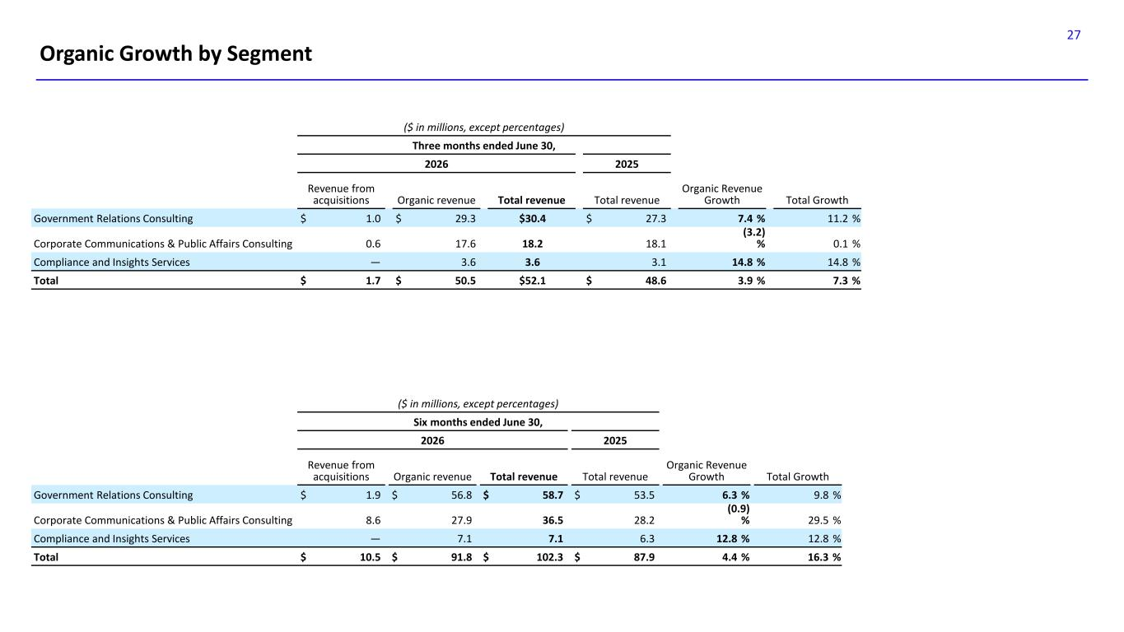
27 Organic Growth by Segment ($ in millions, except percentages) Six months ended June 30, 2026 2025 Revenue from acquisitions Organic revenue Total revenue Total revenue Organic Revenue Growth Total Growth Government Relations Consulting $ 1.9 $ 56.8 $ 58.7 $ 53.5 6.3 % 9.8 % Corporate Communications & Public Affairs Consulting 8.6 27.9 36.5 28.2 (0.9) % 29.5 % Compliance and Insights Services — 7.1 7.1 6.3 12.8 % 12.8 % Total $ 10.5 $ 91.8 $ 102.3 $ 87.9 4.4 % 16.3 % ($ in millions, except percentages) Three months ended June 30, 2026 2025 Revenue from acquisitions Organic revenue Total revenue Total revenue Organic Revenue Growth Total Growth Government Relations Consulting $ 1.0 $ 29.3 $30.4 $ 27.3 7.4 % 11.2 % Corporate Communications & Public Affairs Consulting 0.6 17.6 18.2 18.1 (3.2) % 0.1 % Compliance and Insights Services — 3.6 3.6 3.1 14.8 % 14.8 % Total $ 1.7 $ 50.5 $52.1 $ 48.6 3.9 % 7.3 %

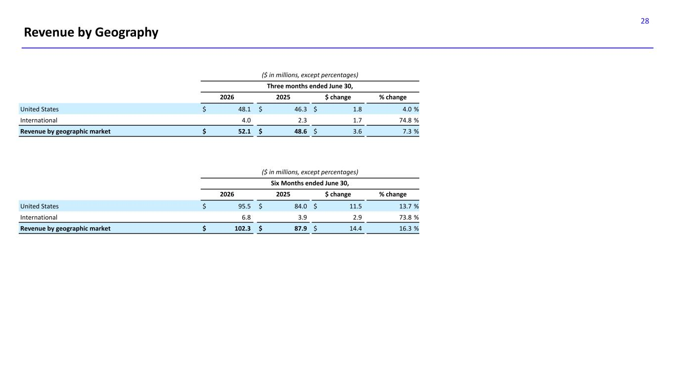
28 Revenue by Geography ($ in millions, except percentages) Six Months ended June 30, 2026 2025 $ change % change United States $ 95.5 $ 84.0 $ 11.5 13.7 % International 6.8 3.9 2.9 73.8 % Revenue by geographic market $ 102.3 $ 87.9 $ 14.4 16.3 % ($ in millions, except percentages) Three months ended June 30, 2026 2025 $ change % change United States $ 48.1 $ 46.3 $ 1.8 4.0 % International 4.0 2.3 1.7 74.8 % Revenue by geographic market $ 52.1 $ 48.6 $ 3.6 7.3 %

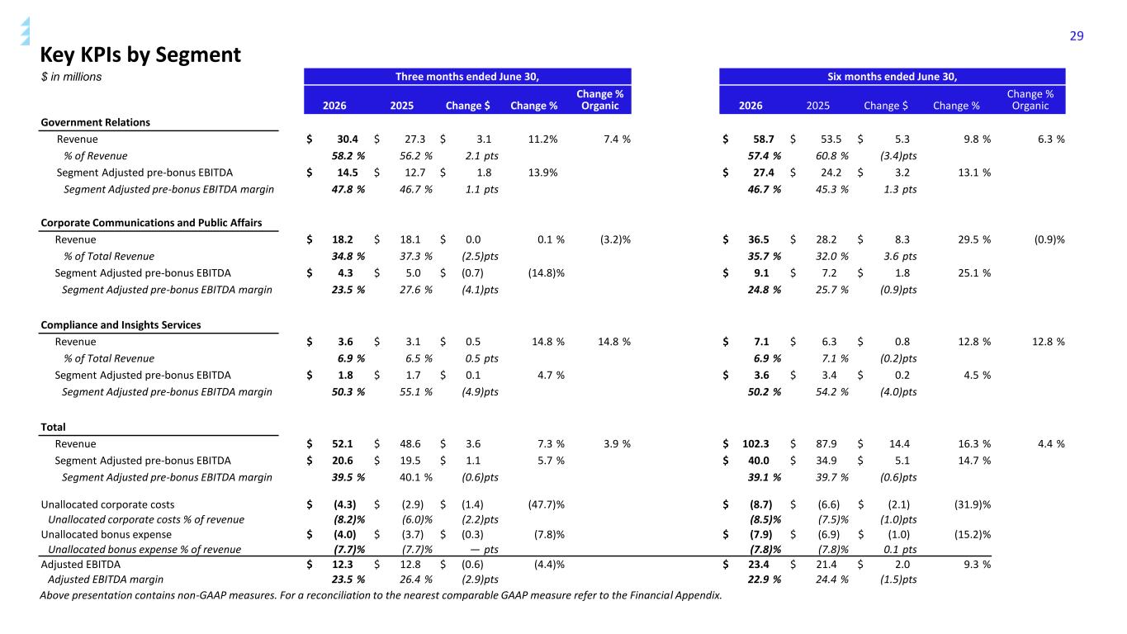
29 Key KPIs by Segment $ in millions Three months ended June 30, Six months ended June 30, 2026 2025 Change $ Change % Change % Organic 2026 2025 Change $ Change % Change % Organic Government Relations Revenue $ 30.4 $ 27.3 $ 3.1 11.2% 7.4 % $ 58.7 $ 53.5 $ 5.3 9.8 % 6.3 % % of Revenue 58.2 % 56.2 % 2.1 pts 57.4 % 60.8 % (3.4)pts Segment Adjusted pre-bonus EBITDA $ 14.5 $ 12.7 $ 1.8 13.9% $ 27.4 $ 24.2 $ 3.2 13.1 % Segment Adjusted pre-bonus EBITDA margin 47.8 % 46.7 % 1.1 pts 46.7 % 45.3 % 1.3 pts Corporate Communications and Public Affairs Revenue $ 18.2 $ 18.1 $ 0.0 0.1 % (3.2)% $ 36.5 $ 28.2 $ 8.3 29.5 % (0.9)% % of Total Revenue 34.8 % 37.3 % (2.5)pts 35.7 % 32.0 % 3.6 pts Segment Adjusted pre-bonus EBITDA $ 4.3 $ 5.0 $ (0.7) (14.8)% $ 9.1 $ 7.2 $ 1.8 25.1 % Segment Adjusted pre-bonus EBITDA margin 23.5 % 27.6 % (4.1)pts 24.8 % 25.7 % (0.9)pts Compliance and Insights Services Revenue $ 3.6 $ 3.1 $ 0.5 14.8 % 14.8 % $ 7.1 $ 6.3 $ 0.8 12.8 % 12.8 % % of Total Revenue 6.9 % 6.5 % 0.5 pts 6.9 % 7.1 % (0.2)pts Segment Adjusted pre-bonus EBITDA $ 1.8 $ 1.7 $ 0.1 4.7 % $ 3.6 $ 3.4 $ 0.2 4.5 % Segment Adjusted pre-bonus EBITDA margin 50.3 % 55.1 % (4.9)pts 50.2 % 54.2 % (4.0)pts Total Revenue $ 52.1 $ 48.6 $ 3.6 7.3 % 3.9 % $ 102.3 $ 87.9 $ 14.4 16.3 % 4.4 % Segment Adjusted pre-bonus EBITDA $ 20.6 $ 19.5 $ 1.1 5.7 % $ 40.0 $ 34.9 $ 5.1 14.7 % Segment Adjusted pre-bonus EBITDA margin 39.5 % 40.1 % (0.6)pts 39.1 % 39.7 % (0.6)pts Unallocated corporate costs $ (4.3) $ (2.9) $ (1.4) (47.7)% $ (8.7) $ (6.6) $ (2.1) (31.9)% Unallocated corporate costs % of revenue (8.2)% (6.0)% (2.2)pts (8.5)% (7.5)% (1.0)pts Unallocated bonus expense $ (4.0) $ (3.7) $ (0.3) (7.8)% $ (7.9) $ (6.9) $ (1.0) (15.2)% Unallocated bonus expense % of revenue (7.7)% (7.7)% — pts (7.8)% (7.8)% 0.1 pts Adjusted EBITDA $ 12.3 $ 12.8 $ (0.6) (4.4)% $ 23.4 $ 21.4 $ 2.0 9.3 % Adjusted EBITDA margin 23.5 % 26.4 % (2.9)pts 22.9 % 24.4 % (1.5)pts Above presentation contains non-GAAP measures. For a reconciliation to the nearest comparable GAAP measure refer to the Financial Appendix.

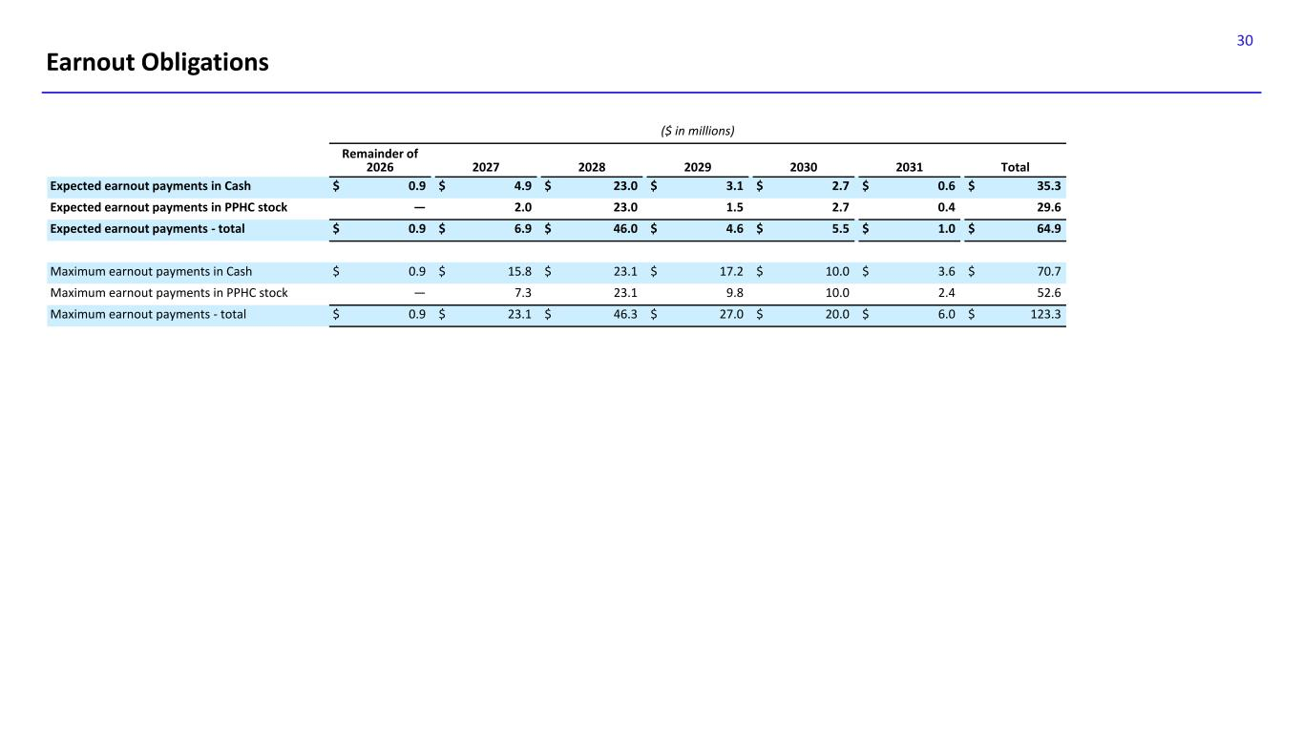
30 Earnout Obligations ($ in millions) Remainder of 2026 2027 2028 2029 2030 2031 Total Expected earnout payments in Cash $ 0.9 $ 4.9 $ 23.0 $ 3.1 $ 2.7 $ 0.6 $ 35.3 Expected earnout payments in PPHC stock — 2.0 23.0 1.5 2.7 0.4 29.6 Expected earnout payments - total $ 0.9 $ 6.9 $ 46.0 $ 4.6 $ 5.5 $ 1.0 $ 64.9 Maximum earnout payments in Cash $ 0.9 $ 15.8 $ 23.1 $ 17.2 $ 10.0 $ 3.6 $ 70.7 Maximum earnout payments in PPHC stock — 7.3 23.1 9.8 10.0 2.4 52.6 Maximum earnout payments - total $ 0.9 $ 23.1 $ 46.3 $ 27.0 $ 20.0 $ 6.0 $ 123.3

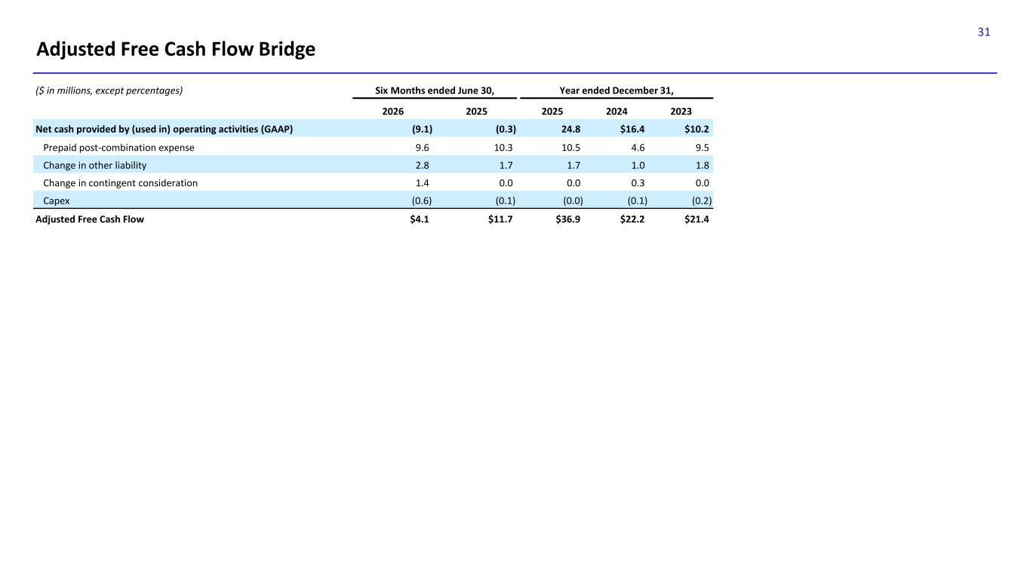
31 Adjusted Free Cash Flow Bridge ($ in millions, except percentages) Six Months ended June 30, Year ended December 31, 2026 2025 2025 2024 2023 Net cash provided by (used in) operating activities (GAAP) (9.1) (0.3) 24.8 $16.4 $10.2 Prepaid post-combination expense 9.6 10.3 10.5 4.6 9.5 Change in other liability 2.8 1.7 1.7 1.0 1.8 Change in contingent consideration 1.4 0.0 0.0 0.3 0.0 Capex (0.6) (0.1) (0.0) (0.1) (0.2) Adjusted Free Cash Flow $4.1 $11.7 $36.9 $22.2 $21.4

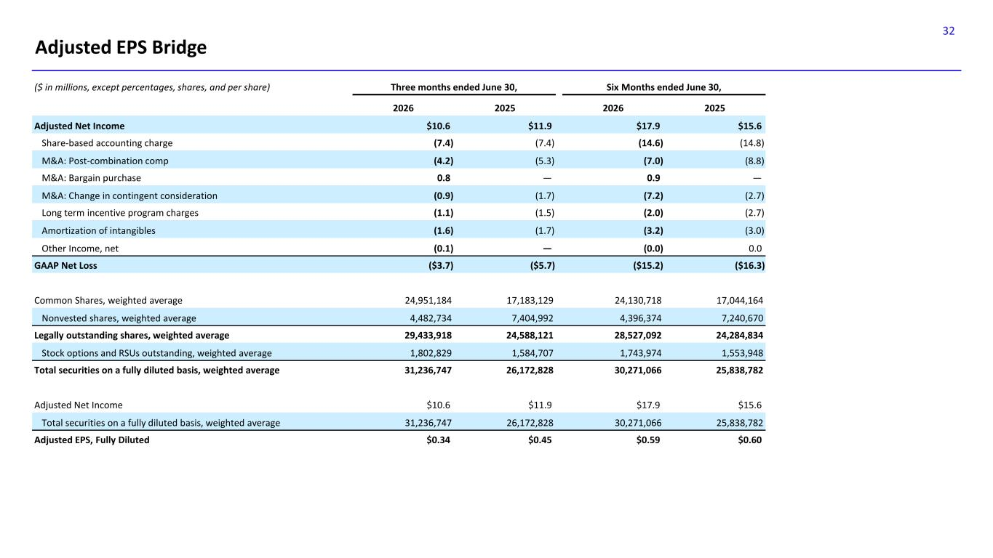
32 Adjusted EPS Bridge ($ in millions, except percentages, shares, and per share) Three months ended June 30, Six Months ended June 30, 2026 2025 2026 2025 Adjusted Net Income $10.6 $11.9 $17.9 $15.6 Share-based accounting charge (7.4) (7.4) (14.6) (14.8) M&A: Post-combination comp (4.2) (5.3) (7.0) (8.8) M&A: Bargain purchase 0.8 — 0.9 — M&A: Change in contingent consideration (0.9) (1.7) (7.2) (2.7) Long term incentive program charges (1.1) (1.5) (2.0) (2.7) Amortization of intangibles (1.6) (1.7) (3.2) (3.0) Other Income, net (0.1) — (0.0) 0.0 GAAP Net Loss ($3.7) ($5.7) ($15.2) ($16.3) Common Shares, weighted average 24,951,184 17,183,129 24,130,718 17,044,164 Nonvested shares, weighted average 4,482,734 7,404,992 4,396,374 7,240,670 Legally outstanding shares, weighted average 29,433,918 24,588,121 28,527,092 24,284,834 Stock options and RSUs outstanding, weighted average 1,802,829 1,584,707 1,743,974 1,553,948 Total securities on a fully diluted basis, weighted average 31,236,747 26,172,828 30,271,066 25,838,782 Adjusted Net Income $10.6 $11.9 $17.9 $15.6 Total securities on a fully diluted basis, weighted average 31,236,747 26,172,828 30,271,066 25,838,782 Adjusted EPS, Fully Diluted $0.34 $0.45 $0.59 $0.60

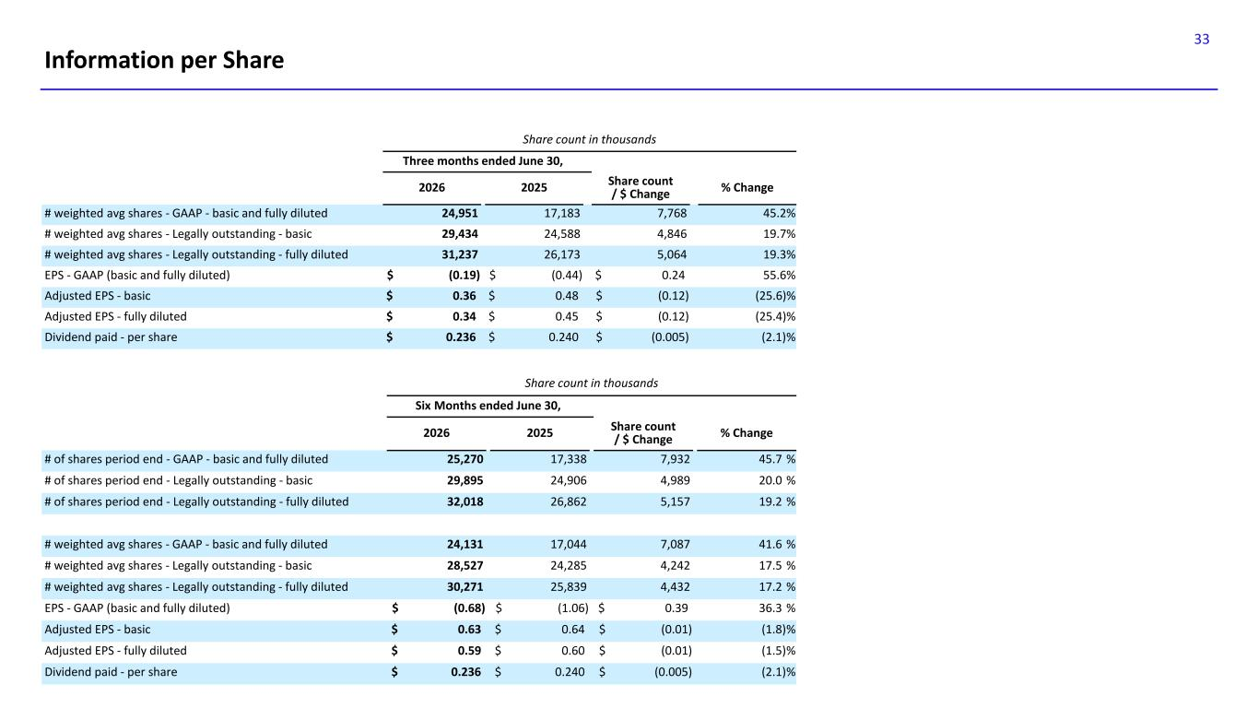
33 Information per Share Share count in thousands Three months ended June 30, 2026 2025 Share count / $ Change % Change # weighted avg shares - GAAP - basic and fully diluted 24,951 17,183 7,768 45.2% # weighted avg shares - Legally outstanding - basic 29,434 24,588 4,846 19.7% # weighted avg shares - Legally outstanding - fully diluted 31,237 26,173 5,064 19.3% EPS - GAAP (basic and fully diluted) $ (0.19) $ (0.44) $ 0.24 55.6% Adjusted EPS - basic $ 0.36 $ 0.48 $ (0.12) (25.6)% Adjusted EPS - fully diluted $ 0.34 $ 0.45 $ (0.12) (25.4)% Dividend paid - per share $ 0.236 $ 0.240 $ (0.005) (2.1)% Share count in thousands Six Months ended June 30, 2026 2025 Share count / $ Change % Change # of shares period end - GAAP - basic and fully diluted 25,270 17,338 7,932 45.7 % # of shares period end - Legally outstanding - basic 29,895 24,906 4,989 20.0 % # of shares period end - Legally outstanding - fully diluted 32,018 26,862 5,157 19.2 % # weighted avg shares - GAAP - basic and fully diluted 24,131 17,044 7,087 41.6 % # weighted avg shares - Legally outstanding - basic 28,527 24,285 4,242 17.5 % # weighted avg shares - Legally outstanding - fully diluted 30,271 25,839 4,432 17.2 % EPS - GAAP (basic and fully diluted) $ (0.68) $ (1.06) $ 0.39 36.3 % Adjusted EPS - basic $ 0.63 $ 0.64 $ (0.01) (1.8)% Adjusted EPS - fully diluted $ 0.59 $ 0.60 $ (0.01) (1.5)% Dividend paid - per share $ 0.236 $ 0.240 $ (0.005) (2.1)%


34

